Plug-In Vehicles
Types
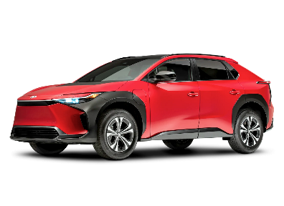 | BEV: Battery Electric Vehicle  Operation is entirely electric. There is no gas engine. Propulsion and cabin warming & cooling are provided only by a very large battery.
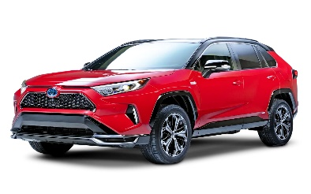 | PHEV: Plug-in Hybrid Electric Vehicle  Designed to operate like a BEV, initial driving will only use electricity. Having a much smaller battery, a gas engine will provide power when plug-supplied electricity is used up.

Charging

 | Level 1: 120-volt AC  Basic home charging, enough overnight to cover most daily driving. You will get about 40 miles in 8 hours. | Level 2: 240-volt AC  Fast home charging, enough overnight  to replenish full BEV capacity. Expect from 200 to 300 miles in 8 hours.
 | DCFC: Direct Current Fast Charge  Fastest option for BEV. Typically not available for PHEV. Time  for charging from 20% to 80% is roughly 30 minutes, though that will vary based on vehicle, charge-level, station and temperature.  Pictured (left) is the CCS plug. A new standard (right) known as NACS will replace it. Adapters are expected from automakers. |  | 

Connections

 | Standard Power  This common household outlet provides 120-volt service for level-1 charging.
 | High Power  This outlet type (NEMA 14-50 pictured) provides 240-volt service for level-2 charging. It is an example of what plug-in vehicle owners add to their home for faster charging and electricity cost discounts.

Cost

The most common question asked is: “How much will my electric bill go up?”
Here are some basic numbers to consider, using 3.5 miles/kWh as typical electric efficiency:
- $0.20/kWh (regular price) driving 1000 miles calculates to $57.14
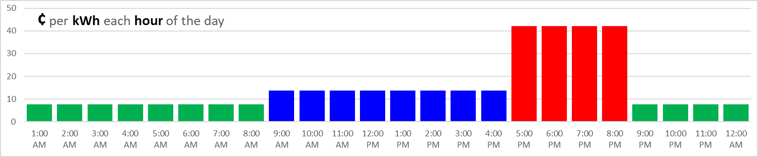
Time-Of-Use pricing from your electricity provider, like the example above, can reduce cost:
- $0.1377/kWh (morning discount) driving 1000 miles calculates to $39.34
- $0.0755/kWh (overnight discount) driving 1000 miles calculates to $21.57
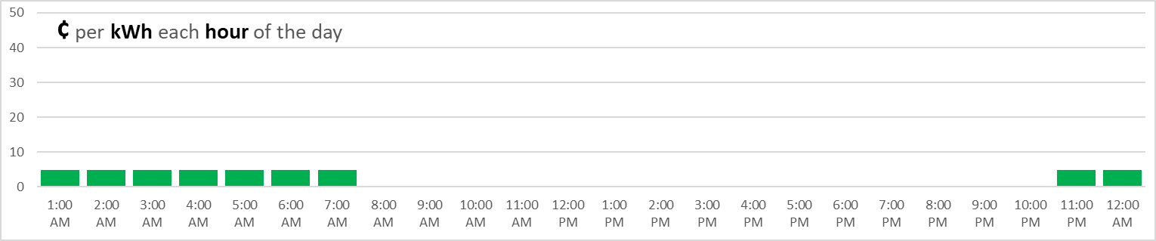
Off-Peak pricing, which restricts charging to low-demand times, can reduce cost even more:
- $0.0487/kWh (off-peak discount) driving 1000 miles calculates to $13.91
For perspective, driving 1000 miles with a 35 MPG gas vehicle at $3.35/gal would cost $95.71

Timing

For charge results (based on 3.5 miles/kWh) related to timing, here are some basics for 30 Minutes:
Type | kW (speed) |  | kWh (quantity) |  | Miles (distance) | 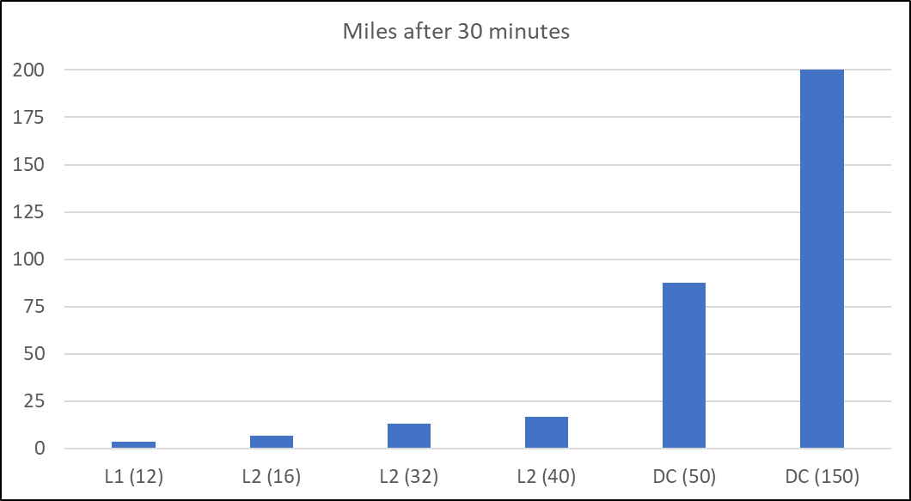
Level-1 (12 amps @ 120 v) | 1.44 |  | 0.72 |  | 2.5
Level-2 (16 amps @ 240 v) | 3.8 |  | 1.9 |  | 6.7
Level-2 (32 amps @ 240 v) | 7.7 |  | 3.8 |  | 13.3
Level-2 (40 amps @ 240 v) | 9.6 |  | 4.8 |  | 16.8
DCFC (50 kW) | 50 |  | 25 |  | 87.5
DCFC (150 kW) | 150 |  | 75 |  | +200

