Toyota Prius User-Guide

Eighth Edition, Eighth Revision for the ICONIC (2004-2009) model


Disclaimer:

All the information stated in this document was provided by Prius owners. None were affiliated with Toyota Motor Corporation, except as customers.

This document is not sanctioned by Toyota Motor Corporation or any of its affiliates.

The ideas, suggestions, and opinions offered in this document have not been endorsed by the manufacturer of those specific components or Toyota Motor Corporation.
Any harm or damage that may result from the application of or the following of any ideas, suggestions, or opinions contained in this document is the sole responsibility of the individual that applied or followed said ideas, suggestions or opinions.

The authors of this document hereby declare that they cannot and will not be held liable, in any fashion, for the content or the use of this document.
DRIVING 2
Just Drive It ! 2
Startup 2
Shutdown 3
Cruise-Control 3
Neutral 3
Reverse 4
Hybrid Driving 5
Brakes 5
Stealth Driving 6
"B" Mode 6
Charge-Level 7
Radio 7
Multi-Display 8
Steering-Wheel 8
CD Player 8
Audio Buttons 8
Inside Air 8
Outside Air 9
UNDERSTANDING 10
MPG Measurement 10
Increasing MPG 10
EPA Estimates 13
Seasonal Cycles 16
Emissions 17
Gas Prices 19
NURTURING 20
Filling the Tank 20
Multi-Display Care 21
Long-Term Storing 21
Polishing 22
Tire Care 22
Tire Upgrades 24
Washing 26
Valet Use 26
Grille Blocking 27
MAINTENANCE 28
Oil Changes 28
Engine Air-Filter 29
Window Wipers 31
Fuel Door 32
Air-Conditioning 33
Light Bulbs 34
OPTIONS 36
SKS: Smart-Entry 36
SKS: Smart-Start 36
SKS: FOB Battery 37
Homelink 38
Electrochromic Mirror 38
Navigation 39
Bluetooth 39
Voice-Recognition 39
VOICE-RECOGNITION 40
Help 40
Navigation - Commands 40
Navigation - Locations 41
Audio 42
Climate 42
Screen 42
OTHER 43
Battery-Pack 43
Rear Hatch 43
External Cargo 46
Side Mirrors 50
Internal Storage 51
Operational Details 52
Transmission 54
Information Sources 55
Informational Materials 57
GLOSSARY 63

DRIVING

Just Drive It !

 | Vital Info | Ignore the technology!  It's too easy to get preoccupied with everything Prius automatically does for you, especially with the Multi-Display providing constant performance information. The hybrid system was designed so you could to drive it like a traditional car. That way, you can enjoy the remarkably smooth & quiet ride. Let the computer worry about how to save gas and reduce emissions.

Startup

 | Step on the Brake | New owners sometimes fall victim to this, not being able to figure out why the car won’t start.  For safety, stepping on the brake before starting has always been highly recommended in all types of vehicles anyway. But in Prius, it is required. Because if you don’t, you’ll find that only the accessories will power-up. The hybrid system itself won’t start until you push the power button while also stepping on the brake at the same time.  If you do make the mistake of not pressing the brake pedal far enough to the floor, a collection of warning the lights by the speedometer will come on. In that case, lift your foot off the brake. Wait a few seconds, and then press it again... only harder this time. Wait a few more seconds, and then press the PARK button. That will reset the system.
 | 12-Volt Jumping | If the 12-volt auxiliary battery is ever drained completely, you can jump it similar to a traditional vehicle. With the Prius OFF (hybrid system & lights), connect the positive-cable to the jump-start terminal (within the black plastic fuse-box, under the Prius hood) then to the positive-terminal on the 12-volt battery of the supplying vehicle (as it is running). Next, connect the negative-cable to the negative-terminal on the 12-volt battery of the supplying vehicle. Then the other end of the negative-cable can be connected to an unpainted metal component under the hood; a very good place for this is the support attaching the engine & motor to the body of the vehicle in the front driver's side corner under the Prius hood. At this point, start the hybrid system. When "READY" appears on the Prius speedometer cluster, you should then disconnect the cables following the opposite order they were connected.  For safety information, greater detail & illustrations, please refer to your Owner's Manual.  A very simple way to confirm you have a good electrical connection before attempting to start is to just turn on the ceiling light. If it illuminates brightly, you know that the supply coming from the donor vehicle is sufficient to successfully jump the Prius. If the light is dim, the connection is bad and you must fix it before proceeding.
 | Winter Heat | Creating heat for the emissions system and heat to keep you warm is fastest and most efficient if you simply drive gently immediately after starting the Prius in the winter. Allowing the engine to run while the Prius is parked takes longer and is less efficient. "Just Drive It !"  Once the heater warms up, resist the temptation to turn up the fan-speed on too high. That will actually decrease the potential heat. Air blasting over the fins of the core too quickly prevents the opportunity to absorb as much heat as possible. Slower air doesn’t. In other words, don't exceed the medium speed setting.
 | Engine Warm-Up | Reducing Emissions is the highest priority for Prius. It strives to remain a AT-PZEV (Advanced Technology - Partial Zero Emission Vehicle) at all times, which means the catalytic-converter must be kept hot… even if it requires consuming some fuel to accomplish that. Fortunately, you still get better than average mileage, even though the engine may run more than you’d expect.

Shutdown

 | Off Confirm | Use the remote or push a door-button (or the one on the hatch) when leaving your Prius. That will confirm that all the doors really did get shut tightly and the power for the hybrid system is off. If you don't, the 12-volt auxiliary battery may get drained completely or the alarm might not be able to protect the car.
 | Whirring Sound | There is a small electric-pump that pumps 3 liters of coolant into a thermal container (to keep it hot) every time you turn the hybrid system power OFF. When the power is turned back ON, the coolant is pump back into the engine. This process reduces emissions, by achieving warm-up much faster than with an engine that would normally have to heat itself up. This process also helps to reduce wear & tear on the engine.

Cruise-Control

 | 24 MPH minimum | Slowing down to less than 24 MPH (39 km/h) will cause the cruise-control "resume" memory to reset. So if you have to slow down or stop, you'll need to set the speed again.
 | MPG | Some owners have observed an increase in MPG from using the cruise-control, others have not. Results vary depending on your particular driving habits and road conditions.
 | Stealth | If you don't have a sensitive enough foot but would still like to enjoy stealth driving on a light traffic road, just set the cruise-control. This can be done all the way up to 42 MPH (68 km/h) on flat or declining terrain without making the engine startup.
 | Smooooooth | The CVT (Continuously Variable Transmission "Planetary" type) makes the cruise-control in Prius remarkably smooth. You'll notice the "no shifting" characteristic of the drive when going up hills and accelerating aggressively. Many consider this smoothness as a luxury feature.

Neutral

 | No Engine | To shift into neutral and keep it there without any chance of the engine starting, do the following:  - Insert the FOB (not necessary if you have SKS, formally known as SE/SS).  - Without stepping on the brake pedal, press the "Power" button twice.  - Use the lever to shift in the Neutral position.

Reverse

 | Beeper Disable | Some owners find the reverse beeper distracting. Although there isn't a method to change the repetitive beeping to just a short warning, there is a way to disable it completely. To do that, carefully follow these steps:  - Switch to the odometer/trip value to display "ODO" by pushing the “ODO TRIP” button shown in the lower-right corner of the photo below. If the speedometer-cluster was already showing “ODO”, make sure to cycle thru each option back to “ODO” again.  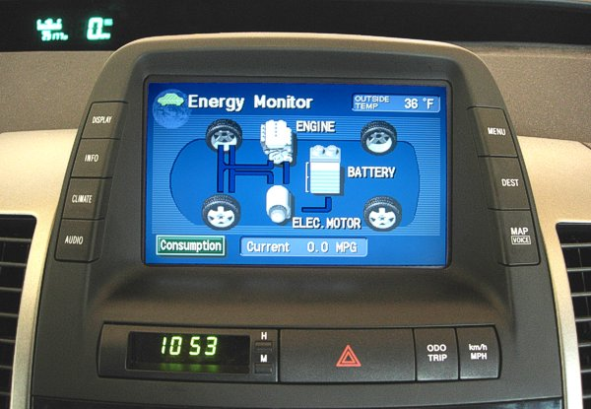  - Power OFF (push the "Power" button).  - Power ON (push the "Power" button again).  - Within 6 seconds of powering back ON, push & hold the button for “ODO” for a minimum of 10 seconds.  - While still holding the button for "ODO", shift into "R" (Reverse), then to "P" (Park).  - "b-on" should display on the odometer/trip-meter now. Push the "ODO TRIP" button to switch the mode to "b-oFF", as shown here:  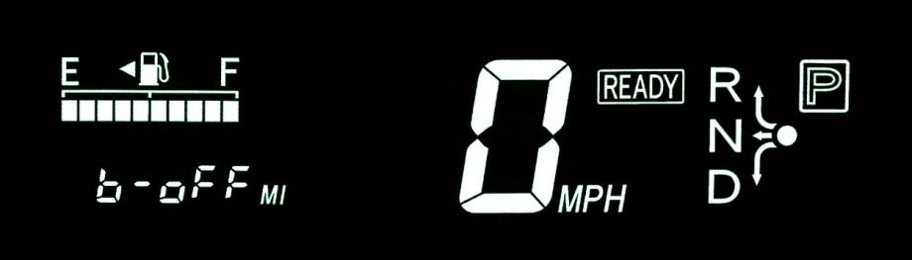  - Power OFF (push the "Power" button). That’s it! The beep should now be disabled.  Note #1: If the sequence above failed, it may have due to the "ODO" setting not having been visible recently. In that case, all you have to do is drive with it that way for a few miles. The next time you try to disable the beeper, the process should work.  Note #2: If you ever disconnect the 12-volt auxiliary battery from the system (or drain it dead), you may have to repeat the disable process again.

Hybrid Driving

 | From a Stop | The gasoline engine is most efficient when running around 70% maximum. So if you can't press lightly enough on the pedal to accelerate using only electricity, go ahead and press a little harder than usual. That brisk (but not aggressive) increase in speed will save a small amount of gas, resulting in an overall efficiency gain.
 | Climbing Hills | The hybrid system has two electric motors. When you encounter a large hill, those motors are automatically taken advantage of. The gasoline engine will rev to its most efficient high-power RPM. That provides thrust directly to the tires, generates electricity for the motor, and recharges the battery-pack all at the same time. So to the surprise of many new owners, large hills don’t drain the system. You’ll still have plenty of reserve power available when you reach the top.
 | On the Highway | Just like with traditional vehicles, efficiency drops the faster you drive on the highway. 60 MPH (96 km/h) is more efficient than 70 MPH (113 km/h). Speeding up to 75 MPH (121 km/h), you'll observe MPG drop even more. It is beneficial to drive slower.
 | Without the Pack | The large electric motor doesn't actually need electricity from the battery-pack. The gasoline engine generates electricity while you drive for immediate use. So quite frequently, you’ll see on the multi-display that the motor is being fed directly from the engine and the battery-pack isn't being used. Sometimes, while both the engine and motor are providing thrust, the engine will also recharge the battery-pack at the same time.
 | A/C Instead | At highway speeds, using the A/C or vent to remain cool will likely result in slightly higher MPG than having the windows open.
 | Cruising | A beneficial technique for efficient cruising is to feather the accelerator pedal at particular times.  Learning to do this is simple and will quickly become second nature with very little practice. (In fact, you may already have that foot control if you in-line skate or bicycle occasionally.) To do it, just lightly reduce pressure on the accelerator-pedal whenever you encounter a section of road that’s perfectly flat or has a slight decline. The MPG indicator will sometimes jump all the way to the +100 mark, even though your speed ends up dropping only 1 MPH. Then lightly push the accelerator-pedal to efficiently regain that speed afterward. Overall, MPG will climb a little bit when each time you do that.  You’ll end up taking advantage of the hybrid design. Changes in the road pitch naturally cause changes in speed anyway. Using the multi-display and large digital speedometer helps you discover when gains from that are possible.

Brakes

 | Regenerator | When you reduce pressure on the accelerator-pedal or use the brake-pedal, excess speed turns a motor, causing regeneration of electricity to recharge the battery-pack. The regenerator takes advantage of the kinetic energy that would have otherwise been lost. The brake pads & shoes are not used as much as in a traditional vehicle. This not only makes the Prius more efficient, it also indicates the brakes will last longer.

Stealth Driving

 | Engine Off | While the gasoline engine is off and you’re driving using just battery power, the mode you’re in is called "stealth" (since the vehicle motion is totally silent).  Invoking "stealth" is easy once the engine has warmed up (and you aren't running the A/C or Heater too heavily). While driving, just find a street section without any inclines then lift your foot from the accelerator-pedal. The engine will shut off within a few moments. Once it does, lightly place your foot back on the accelerator-pedal to continue driving with only electricity. Another way to invoke stealth is to just stop completely, that will make the engine shut off.
 | Up to 42 MPH | The 50 kW electric motor is designed to propel the Prius up to 42 MPH (68 km/h). It takes a steady foot though. Slower speeds, like 35 MPH (56 km/h) and 30 MPH (48 km/h), are easier. Beyond that maximum speed or in conditions when additional power is needed, the electric motor works in combination with the gasoline engine. Though, you will discover above 42 MPH (68 km/h) that there are times when the engine will spin (pistons in motion) without any fuel being consumed; it is a normal function of the Planetary-CVT.
 | Acceleration | Accelerating in "stealth" can be very slow. Also using the gasoline engine is both quicker and more efficient, so don't be afraid to consume a little bit of gas. Remember that even if you use the battery and get "+100 MPG", the engine must run later to recharge it. So short-term gains may actually result in an overall loss.
 | A/C | The A/C is electric. So as long as the battery-pack has ample supply remaining, the engine will typically remain off while you drive in “stealth”.
 | Heater | Until coolant temperature remains drops below 145 F degrees (62.8 C) and the catalytic-converter is still warm, you can continue to drive in “stealth” even with the heater running.
 | Be Careful ! | Be careful while driving in "stealth", especially in parking lots. Some people use only their ears to verify that it's safe, not their eyes! So having a car that's completely silent means you'll probably have someone step out in front of it without even realizing you’re driving right at him or her. And fortunately, the quiet actually makes it easier to hear children (who commonly don’t look anyway).

"B" Mode

 | On/Off Anytime | You can engage or disengage engine-braking at anytime while driving.
 | Engine-Braking | Avoid using this mode unless absolutely necessary, since it will cause MPG to drop. There is no charging benefit over regular (foot pedal) braking either.  "B" mode works like an exhaust brake on a large truck (except, it's totally silent). The engine is used to slow down the vehicle, allowing you to reduce reliance on the regular brakes. So for steep declines, like driving down a mountain, it's a great way to avoid overheating caused by friction from the brake drums & shoes.
 | Winter Slowing | A special use of "B" is the ability to shift into it on-the-fly without having to take your eyes off the road. Finding yourself taking a turn on snow or ice a little bit too fast, you'll discover "B" does an absolutely fantastic job of slowing the car enough to retain traction without any risk whatsoever of the wheels slipping from braking too hard... since you aren't using the brakes at all.

Charge-Level

 | Green | 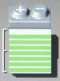 | When the charge-level of the battery-pack (displayed on the Energy Screen) exceeds 6 bars, the color will change to Green. This is simply a convenience feature to make the SOC (State-Of-Charge) easier to notice.  Once the level reaches 8 bars, no further detail is shown even though charging continues. That is because the battery-pack isn’t actually full. What you see is actually just 80% capacity. The range above that is rarely utilized, since that shortens the lifetime of the battery-pack. So, it isn’t included on the display.
 | Blue | 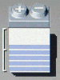 | When the SOC is 3 to 6 bars, the color will be displayed as Blue.  This level is what the battery-pack will be at the most. For maximum life, it is the ideal. So you’ll often witness behavior on the Energy Screen that contributes to a SOC within this range.  In short, don’t get too preoccupied with SOC. The system will properly maintain it for you automatically.
 | Pink |  | From time to time, you may witness the Pink color. That’s when the SOC drops below 3 bars.  When this happens, don’t panic! New owners often do, even though there is absolutely nothing wrong. It is simply an indication that the engine will begin running soon to replenish the SOC. That’s all.  Even without any bars showing at all, the battery-pack still has 40% capacity available. But since deep-discharges (a condition that shortens the life of the battery-pack) are automatically prevented, there is no reason to ever display anything below that level. So, it doesn’t.

Radio

 | Channel Scan | Press the "SCAN" button by the radio tuner knob. It will begin scanning for radio channels. When it does finds a station, a few seconds will play, then it will automatically scan for the next. Press the "SCAN" button again when you want the scanning to stop.  If you press then hold the "SCAN" button, only your preset radio channels will be scanned.
 | Tuner Adjust | In additions to using the knob on the dashboard, you also have the option of adjusting the tuner for the radio via the buttons on the steering-wheel. Just press & hold either the up or down button with your left thumb.

Multi-Display

 | Screen Off ! | Many new owners accidentally discover the off button. Innocently pressing it causes them to panic, because the Multi-Display unexpectedly goes black. Don’t worry though. It’s easy to turn back on.  - Press the "INFO" button on the left, next to the Multi-Display.  - On the screen that appears, press the "Trip Info" button.

Steering-Wheel

 | Tilting | You won’t notice the lever unless you’re specifically looking for it. Reach underneath, feeling for an opening. When you find it push forward. The lever will swing out, releasing the steering-wheel. Then you can tilt it. Pulling the lever back toward you afterward will lock the steering-wheel into the new position.

CD Player

 | Changing | Holding the track-change button on the steering-wheel, rather than just quickly pressing it, will cause the CD to be changed instead.

Audio Buttons

 | Audio Button | Pressing the "Audio" button next to the Multi-Display will reveal the Radio Preset or CD Control screen, depending on what is playing at that moment.  Pressing the "Audio" button an additional time will return you to the screen you were previously viewing, "Consumption" or "Energy Monitor" or "Navigation".
 | Mode Button | Pressing the "Mode" button on the Steering-Wheel toggles between the AM, FM1, FM2, and CD modes of the audio system.  Holding the "Mode" button for a few seconds will toggle the power for the audio system on & off.

Inside Air

 | Recirculate | Avoid using this mode during the winter, since it contributes to frost on the inside of the windows.  Recirculating warm inside air will prevent the engine from needing to run as often; however, the moisture you naturally exhale will build up after awhile. Allowing the fresh cold air from outside to be drawn in will keep the humidity low. The resulting minor MPG penalty is well worth always having clear glass.

Outside Air

 | Vent | Changing the "Air Conditioner" mode to draw in air directly from the outside for cooling rather than allowing it to be influenced by the heater-core isn’t an obvious process, but it is surprisingly easily once you know how.  Many people call this "opening the vent" and it is used most frequently in the summer when you want to avoid having to turn on the A/C.  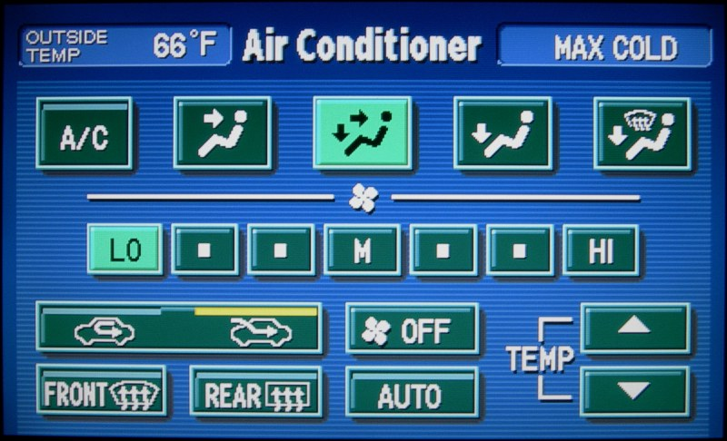  Here’s how:  - Press the "A/C" button so the yellow-bar above it disappears.  - Press the circulation button so the yellow-bar above the "outside car arrow" appears.  - Reduce the temperature to the lowest setting, called "Max Cold".  The Multi-Display will then resemble the example above. Below is a photo of the button layout for the newer model; different settings are enabled (not vent).  You may alter the blowing location to any of the 4 settings available and the blowing speed to any of the 7 settings available.  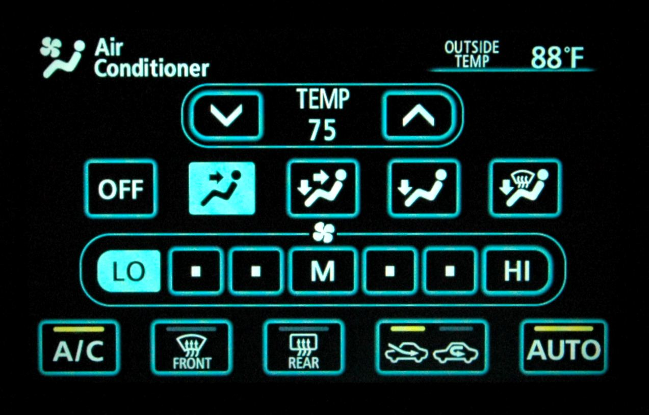

UNDERSTANDING

MPG Measurement

 | Lifetime | LIFETIME is the most useful measurement. Total miles driven, divided by total gallons consumed, informs you how efficiently the car has performed overall.
 | Tank | TANK is the measurement between each fill up. You press the RESET button when the tank is full. The results are informative, but not perfectly accurate. In cold weather, the bladder inside the gas tank shrinks. This reduces the overall capacity making the "full" level variable. Also, "full" can be misrepresented if the pump doesn't shut off at the proper time. These factors make calculations based on fill-up less accurate.
 | Trip | TRIP is mostly for fun, since a multitude of variables can affect the measurement to a single destination. Watch the 5-minute summary segments shown on the multi-display. Remember though, if you were to start a drive downhill, with a tail wind, a warm engine, a fully charged battery-pack, and a warm outside temperature, the MPG would be very impressive for that particular trip. But then if the return trip back was uphill, against the wind, with a cold engine, a drained battery-pack, and a cold outside temperature, the MPG would appear very disappointing. In summary, trip results can vary greatly. The overall average is what really matters.
 | Sudden Drop | Tire pressure may have gone down. For every 10 F degrees colder, pressure will naturally decrease by 1 PSI. Verify you still have as much air in the tires as you think they do.  Increased use of the Heater or A/C (which includes the defroster) will force the engine to run more often. Try a less demanding setting.  When the temperature drops below freezing, you’ll probably notice the engine has to run quite a bit longer to create heat for the catalytic-converter. This is to keep the Prius emissions extremely low. Avoid driving short trips; instead, take advantage of the time after warm up is complete by running several errands at once.  A dirty engine air-filter will also cause the MPG to drop. Check it routinely, especially as the seasons change. Once flow becomes visibly restricted (dark colored rather than white), the time has come replace it.
 | Tire Break-In | Don’t forget that new tires require a break-in period. Before that the tire surface and tread edges will be rough, causing MPG to be lower than you expect. It takes about 1,000 miles (1,600 km) before enough wear (barely visible to a trained eye) occurs to allow less abrasive contact with the road. And since front tires wear more than those in the rear, expect another break-in period the first time the rear tires are rotated to the front. Fortunately, that reduced MPG will only last a few hundred miles.

Increasing MPG

 | A/C & Heater | Minimal use is the key. Using the Heater or the A/C (which includes the defroster) on anything but a low setting may prevent the engine from shutting off. That will reduce MPG. So, try to avoid high demand use. Fortunately, on the highway using the A/C is still more efficient than opening the windows.
 | On the Highway | Just like with traditional vehicles, efficiency drops the faster you drive on the highway. 60 MPH (96 km/h) is more efficient than 70 MPH (113 km/h). Speeding up to 75 MPH (121 km/h), you'll observe MPG drop even more. It pays to drive slower (obey the speed-limit). Think of it this way, pedaling a bicycle rapidly takes much more energy than pedaling at a moderate rate.
 | YMMV | "Your Mileage May Vary" That simple statement about the EPA estimates shown on the new vehicle window sticker is often overlooked, yet it makes a significant difference depending on the type of driving you do. Reading this quote provided by the EPA about Prius reveals why: "Actual Mileage will vary with options, driving conditions, driving habits and vehicle's condition. Results reported to EPA indicate that the majority of vehicles with these estimates will achieve between 51 and 69 mpg in the city and between 43 and 59 on the highway."  EPA tests are basic generalizations (performed under ideal conditions) intended to make vehicle comparisons easier, not to specify what MPG you will actually get. In fact, they rarely actually reflect the MPG in real-world driving experiences.
 | Driving | Brisk Acceleration is an often misunderstood benefit. There's no need to hold back. A gasoline engine works more efficiently when running at higher RPM, about 70 percent of maximum. Take advantage of that by getting to cruising speed quickly (but not aggressively, please drive safely). And remember, while the engine running it is also generating electricity for later use.  Coast whenever you have the opportunity. Using the feather technique helps. By lifting your foot lightly from the accelerator-pedal, you can invoke an efficient computer-controlled glide without decelerating much at all (less than 1 MPH). With good road conditions and a bit of practice, you'll find yourself doing this instinctively.  Look Ahead. If you see a light turning red or a need to slow down in the distance, there's no reason to continue holding the accelerator-pedal. Remove your foot and allow the generator to decelerate the Prius. That will increase your MPG, charge the battery-pack, and prolong the life of your brakes.
 | Tire Care | 42/40 PSI (2.9/2.8 bar) is what many Prius owners strongly recommend. The original tires for the Classic Prius support a maximum cold pressure of 50 PSI (3.4 bar) and for the Iconic Prius 44 PSI (3.0 bar). So that pressure increase is well within the design specifications. Many of the alternate tires available support a maximum cold pressure of 44 PSI (3.0 bar) too. Whatever you decide, just remember that low pressure results in a MPG drop and the tires wear out faster. Tires will not bulge like in decades past; manufacturers provide much better quality now which maintains a flat contact surface all the way up to the maximum pressure.  Every 5,000 miles (8,000 km) the tires should be rotated, for best lifetime performance. Rotation is preferred in a roll-back, roll-forward pattern.  Measuring the PSI should be done only when the tires are cold, since driving heats up the air inside the tires making the results inaccurate... giving you the impression more pressure is higher than it really is.  Check Often since temperature causing pressure to drop, 1 PSI for every 10 F degrees. Air will naturally leak out from normal use too.
 | 87 Octane Gas | Prius was designed to run with 87 Octane gasoline (85 in high altitudes). Some owners have experimented with higher octanes, but found there wasn't any MPG improvement. Also, bear in mind that higher octane gasoline may trigger an emission sensor alert. So just save money and continue using the less expensive 87 octane gas.
 | "B" Mode | Avoid using this mode unless absolutely necessary, since it will reduce MPG.
 | External Loads | Any type of accessory rack for carrying external loads (Receiver, Roof, or Strap-On) will cause aerodynamic drag. So, expect a MPG drop when you use one.
 | Engine Warm-Up | Short Trips are horribly inefficient for all vehicles. Prius is no exception; however, it’s far more noticeable since the Multi-Display provides immediate feedback to actually show you the lower MPG. The efficiency benefits of the system are not utilized until after warm-up is complete... that's engine, emissions system, and tires. So try to run several errands at once to take advantage of an already warmed up car.  PZEV (Partial Zero Emission Vehicle) is what Prius strives to remain whenever active, even during warm-up. That means the catalytic-converter must be kept hot even if that requires using some gas to do it. Fortunately, you still get better than average mileage, even if the engine doesn't shut off right away.
 | 5W-30 Oil | 5W-30 oil is strongly recommended (real or synthetic).  If a service person puts 10W-30 in by mistake, you may complain since it will negatively impact your MPG slightly and may affect performance in below freezing temperatures. The text printed on the engine oil cap clearly states 5W-30 should be used.
 | Synthetic Oil | Owners have observed minor MPG improvements by switching to synthetic oil.  Plus, since it protects the engine better than real oil and makes extremely cold startups even easier, switching from real oil should be a simple choice.
 | Oil Level | Too much oil can decrease MPG. Verify the level is never above the max mark on the dipstick.  Unfortunately, overfilling is a problem commonly overlooked. Oil change services routinely pump oil from large barrels, rather than using quart-size bottles. That makes overfilling very easy to do. Taking a moment afterward to check afterward is truly beneficial.
 | Measurement | The multi-display averages optimistically, so it will usually read about 1.4 MPG too high for most owners. The "bladder effect" (caused by the bladder in the gas tank shrinking due to temperatures below freezing), which is very noticeable in the Spring & Fall, causes the readout value and manual calculations to vary greatly for individual tank measurements. Averaging several fill up amounts documented at the gas station will provide the actual MPG you've been getting. For an example of how to do this, refer to this webpage... Hhttp://john1701a.com/prius/prius-data.htm
 | Break-In | For the first 200 Miles (322 km):  • avoid rapid deceleration (hard stops)  • avoid high speeds (more than 70 MPH, 113 km/h)  For the first 600 Miles (966 km):  • avoid rapid acceleration  • avoid racing (high RPM) the engine  After roughly 10,000 Miles (16,100 km):  • enjoy a MPG increase, from the moving parts having loosened  Even at 30,000 Miles (48,300 km):  • you may continue observe minor MPG increases as the car ages

EPA Estimates

 | Purpose | The intent of the EPA efficiency values posted on each new vehicle window-sticker is only to provide a basis for comparison, not an actual MPG expectation... as commonly believed.  Read the fine-print on this digital scan of an actual 2004 Prius window-sticker, keeping in mind that even though the values changed beginning for 2008 the large numbers continue to mislead:  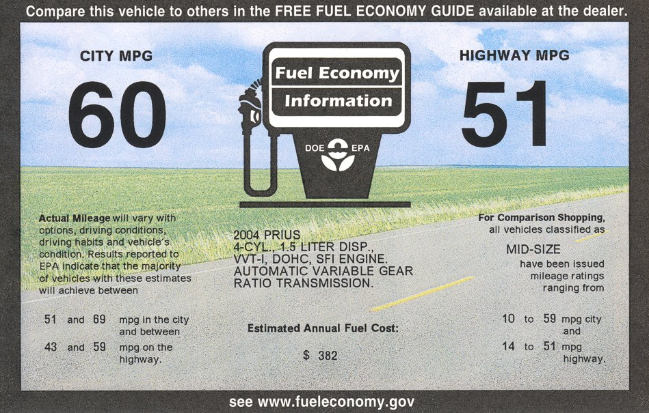  Real-World results vary significantly. That’s what those smaller numbers express. There is a range of efficiency owners can expect, not those specific City & Highway values shown in large print.
 | Ideal Conditions | Pay very close attention to the fact that the EPA tests are all performed under ideal conditions, those that don't actually reflect real-world temperature or driving habits. Think of those values reported as optimal, not realistic. You may be able to achieve them from occasionally, but not on a routine basis.
 | Ranging Values | As mentioned on the window-sticker, there is a range of expected efficiency values. The large numbers are really nothing but an average. In fact, the MPG isn't even constant for each vehicle. Driving conditions, method of driving, and the influence of multiple drivers can all have a major impact, causing fluctuation. Tank-to-tank measurements can vary quite a bit as a result, without even taking into account the effect of seasonal cycles. None of these factors are represented when the EPA tests are performed.
 | Unrealistic Speed | Back when the testing procedures were established way back in 1977, the speed limit on most highways was only 55 MPH (88.5 km/h). That’s quite unrealistic for travel nowadays. Many drivers cruise at speeds much faster. That causes a significant efficiency reduction, which is not indicated on the window-sticker.
 | Unrealistic Climate | The "perfect summer day" climate portrayed during the testing is not what people actually drive their vehicle in a great majority of the year. Winter extremes cause efficiency to drop significantly, as do the Summer extremes. Factors such as temperature, wind, and moisture have a major influence, causing the vehicle performance to be reduced in the form of lower MPG. To make matters worse, the use of the Heater or A/C also contribute to lower MPG.
 | Gentle Acceleration | The testing procedures utilize gentle acceleration, which does not represent the way people actually drive anymore. For example, when merging onto a highway now, much more harsh acceleration is required. The tests don’t reflect the MPG penalty that causes. So unless you acceleration as slowly as when the test was performed, efficiency will be lower.
 | Fuel Type | EPA testing is done using 100% gasoline, which is the most efficient fuel available for a Prius to run on. Those owners using the cleaner fuel alternative called "E10", which is a 10% ethanol and 90% gasoline blend, have a clear disadvantage. That blend is approximated 3.4% less efficient. In simple terms, that means achieving 50 MPG using E10 could actually achieve 51.7 MPG using 100% gasoline instead.
 | Testing Procedures  (revised starting 2008) | The following (from Hhttp://www.fueleconomy.gov/feg/info.shtmlH ) explains how the EPA tests are actually performed, notice how results can be quite a bit lower if you live in the north or if you drive fast:  The fuel economy estimates are based on results of tests required by the U.S. Environmental Protection Agency (EPA). These tests are used to certify that vehicles meet the Federal emissions and fuel economy standards. Manufacturers test pre-production prototypes of the new vehicle models and submit the test results to EPA. EPA re-tests about 10% of the tested vehicles to confirm manufacturer's results in EPA's lab. The vehicles are driven by a professional driver under controlled laboratory conditions, on an instrument similar to a treadmill. These procedures ensure that each vehicle is tested under identical conditions; therefore, the results can be compared with confidence.  There are two different fuel economy estimates for each vehicle in the Fuel Economy Guide, one for city driving and one for highway driving. To generate these two estimates, separate tests are used to represent typical everyday driving in a city and in a rural setting. Two kinds of engine starts are used: the cold start, which is similar to starting a car in the morning after it has been parked all night; and the hot start, similar to restarting a vehicle after it has been warmed up, driven, and stopped for a short time.  The test used to determine the city fuel economy estimate simulates an 11-mile, stop-and-go trip with an average speed of 20 miles per hour (mph). The trip takes 31 minutes and has 23 stops. About 18 percent of the time is spent idling, as in waiting at traffic lights or in rush hour traffic. The maximum speed is 56 mph. The engine is initially started after being parked overnight. Vehicles are tested at 68 F to 86 F ambient temperature.  The test to determine the highway fuel economy estimate represents a mixture of "non-city" driving. Segments corresponding to different kinds of rural roads and interstate highways are included. The test simulates a 10-mile trip and averages 48 mph. The maximum speed is 60 mph. The test is run with the engine warmed up and has little idling time and no stops (except at the end of the test).  NOTE: To make the numbers in the Fuel Economy Guide more useful for consumers, the EPA adjusts these laboratory test results to account for the difference between controlled laboratory conditions and actual driving on the road. The laboratory fuel economy results are adjusted downward to arrive at the estimates in the Fuel Economy Guide and on the labels seen on new cars, light trucks, and vans. The city estimate is lowered by 10% and the highway estimate by 22% from the laboratory test results. Experience has proven that these adjustments make the mileage estimates in the Fuel Economy Guide correspond more closely to the actual fuel economy realized by the average driver.
 | 2008 Revisions | Beginning with 2008 models, the EPA testing procedures were updated to also include the following efficiency-lowering influences:  - Faster Speeds & Acceleration  - Air Conditioner Use  - Colder Outside Temperatures  Mileage will still vary based upon the following:  - How & Where You Drive  - Vehicle Condition & Maintenance  - Fuel Variations  - Vehicle Variations  - Engine Break-In  Detailed Testing Information:  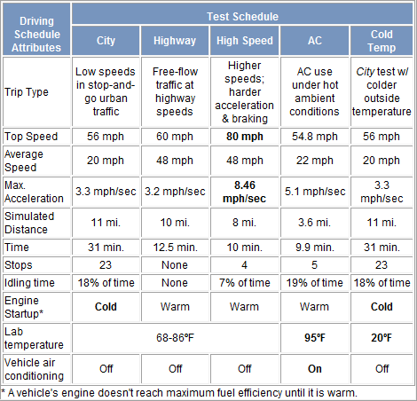  http://www.fueleconomy.gov/feg/fe_test_schedules.shtml for more information.

Seasonal Cycles

 | All Vehicles | Seasonal cycles affect all vehicles, not just hybrids. But with a Prius, you are much more aware of the MPG changes due to having a Multi-Display constantly informing you of efficiency differences. With traditional vehicles, owners typically were not aware how much of an affect climate has on their vehicle’s performance. They just assume MPG remains relatively constant throughout the entire year. In reality, that isn’t even remotely correct. Large fluctuations are actually normal.
 | Temperature &  Lifetime Measure | The difference between the warm & cold months is a significant change in MPG. In the winter, the engine takes longer to warm-up, and the engine is needed to operate the heater. Both cause more fuel to be consumed. The density of cold air is thicker, making it hard to push through. This reduces efficiency. In the summer, running the A/C to keep you cool requires electricity from the battery-pack. That electricity is ultimately derived from the engine, which consumes fuel to accomplish that. So, the more you use the A/C, the lower MPG will be.  These examples of real-world data (from Hhttp://john1701a.com/prius/prius-data.htmH ) clearly the shows a cyclical effect of efficiency caused by winter and summer (specifically in Minnesota):  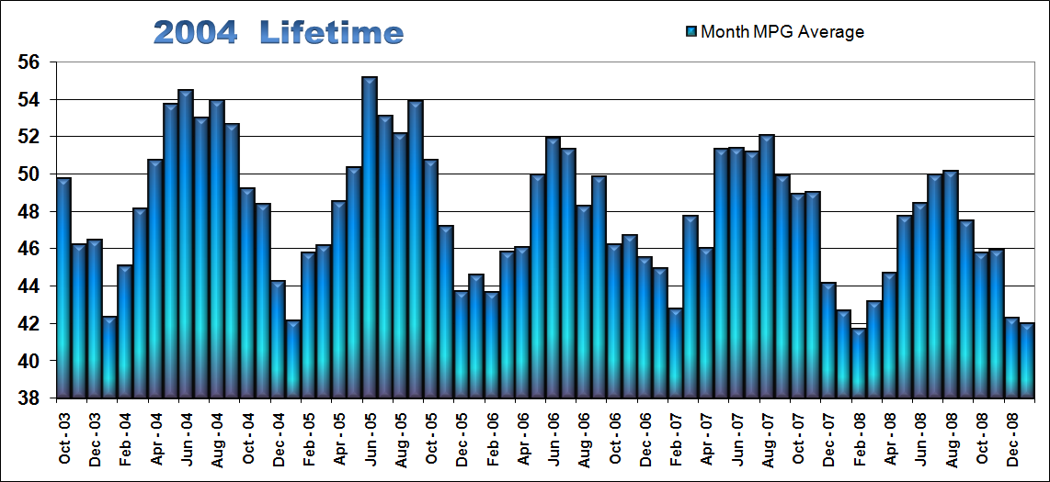  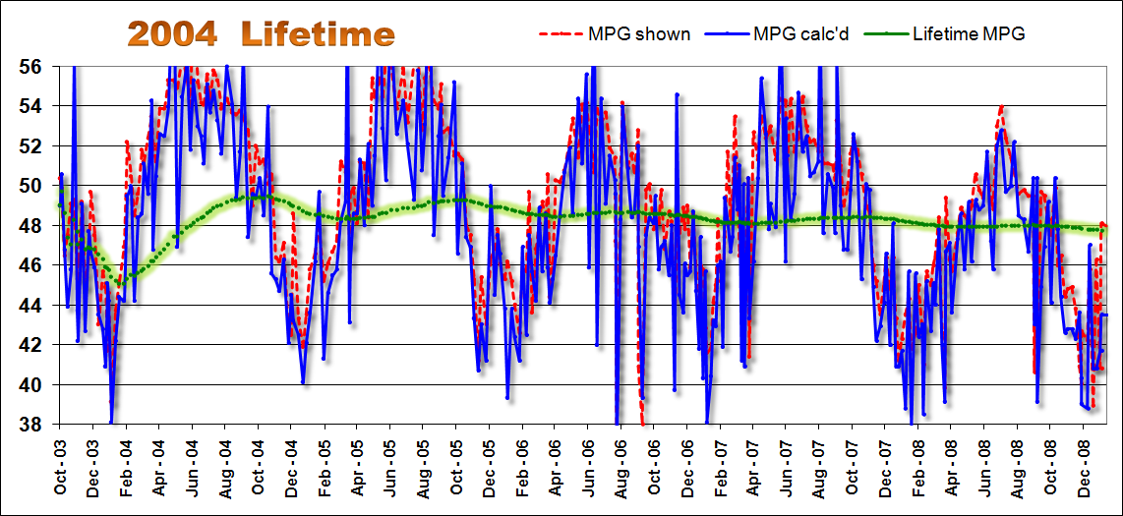  The top graph, spanning over 5 years of time, is a summary of month averages. Below it is data plotted using individual fill-up points instead. It clearly shows wild fluctuations. These are based heavily on the influence of temperature. This is why the measure of Lifetime MPG is the only method for judging true efficiency performance. Long durations will reveal an on-going average value, which is extremely easy to see by that nearly straight line among the otherwise seemingly chaotic graph.
 | Seasonal MPG | It is sometimes helpful to consider efficiency based on seasonal data, by grouping months with like temperatures together. The following graph is a collection of over 5 years of data from a Prius used in Minnesota. Notice how the group of warmer months delivers MPG much higher than those in the winter. That follows the pattern depicted in the lifetime graphs but in a summarized format.  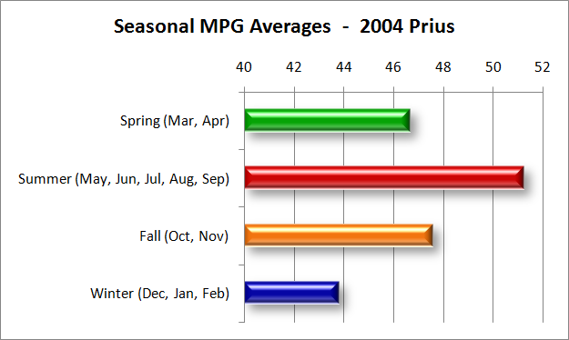
 | Traffic | It is common for people to forget how much traffic patterns change during the winter. Slippery roads cause major delays, increasing driving time significantly. So even with the benefit of the hybrid system, there is still a very real plenty for getting stuck in that traffic heavy traffic.
 | Heater | Heat to keep you warm in the winter comes from the engine. Hot coolant is circulated through the heater-core as long is possible to continue heating the air. But eventually, it cools. At that point, 145 F degrees (62.8 C), the engine must restart to warm the coolant again.
 | A/C | The A/C system in Prius is powered by an electric pump, not a pump powered by a belt connected directly to the engine. That means in can run for a modest amount of time exclusively using only the battery-pack, providing a significant efficiency benefit during the summer.

Emissions

 | Prius Rating | Prius (Iconic model) has earned a CARB emission rating of: AT-PZEV
 | Engine Light ! | After filling the gas tank, failing to completely tighten the cap will trigger the engine light. That warning informs you that the unsecured cap is allowing evaporative emissions to escape from the system. Simply twist the cap a little bit more. The light will automatically turn off afterward.
 | Categories | Just because a vehicle is labeled as a "Hybrid", that does not mean the vehicle is actually any cleaner. In fact, some hybrids emit the same amount of smog-related pollution as a common traditional vehicle. Sadly, there are even a few that are dirtier. So don’t assume a technology is really green. Use the following information to verify the vehicle’s true status.  CARB (California Air Resources Board) defines the following categories to help you identify how clean the vehicle is (from Hhttp://www.arb.ca.gov/msprog/zevprog/factsheets/driveclean.pdfH ):  LEV (Low Emission Vehicle)  The least stringent emission standard for all new cars sold in California beyond 2004.  ULEV (Ultra Low Emission Vehicle)  50% cleaner than the average new 2003 model year vehicle; rated for 100,000 miles.  SULEV (Super Ultra Low Emission Vehicle)  90% cleaner than the average new 2003 model year vehicle; rated for 120,000 miles.  PZEV (Partial Zero Emission Vehicle):  Meets SULEV tailpipe emission standards, has a 15-year / 150,000 mile warranty,  and has zero evaporative emissions.  AT-PZEV (Advanced Technology - PZEV):  Meets SULEV tailpipe emission standards, has a 15-year / 150,000 mile warranty,  has zero evaporative emissions and includes advanced technology components.  ZEV (Zero Emission Vehicle):  Zero tailpipe emissions, 98% cleaner than the average new 2003 model year vehicle.  Use http://www.fueleconomy.gov/feg/findacar.htmH to look up detail, including emission-rating and efficiency-estimates, for vehicles dating all the back to 1985.
 | Measurements | Light Duty Vehicles (LEV/ Tier II Standard grams/mile for 120,000 miles /11 years)  Bin* = EPA (Environmental Protection Agency) category  *EV = CARB (California Air Resources Board) category  Light Duty Vehicles = Passenger Cars & Trucks (pickup, minivan, van, suv) up to 8,500 pounds  NOx = nitrous oxides (combines with hydrocarbons in sunlight to form smog)  NMOG = non-methane organic gases (combines with NOx in sunlight to form smog)  CO = carbon monoxide (colorless, odorless, poisonous gas)  PM = particulate matter (tiny particles of solid matter that lodge in the lungs)  HCHO = formaldehyde (lung irritant and carcinogen)  Score = Air-Pollution Scale
   | NOx | NMOG | CO | PM | HCHO | Score
  Bin1 & ZEV | 0.00 | 0.000 | 0.0 | 0.00 | 0.000 | 10
  PZEV | 0.02 | 0.010 | 1.0 | 0.01 | 0.004 | 9.5
  SULEV | 0.02 | 0.010 | 1.0 | 0.01 | 0.004 | 9
  Bin2 | 0.02 | 0.010 | 2.1 | 0.01 | 0.004 | 9
  Bin3 | 0.03 | 0.055 | 2.1 | 0.01 | 0.011 | 8
  Bin4 | 0.04 | 0.070 | 2.1 | 0.01 | 0.011 | 7
  ULEV | 0.07 | 0.055 | 2.1 | 0.01 | 0.011 | 7
  Bin5 & LEV | 0.07 | 0.090 | 4.2 | 0.01 | 0.018 | 6

Gas Prices

 | Planning Ahead | This graph was generated using data from actual fill-ups over the past 8 years in Minnesota. It was added to the document simply for the benefit of Prius (and other hybrid) owners, to make them feel better about their purchase decision. Rather than believing the so-called experts that claimed this would never happen to the price of gas, the owners planned ahead.  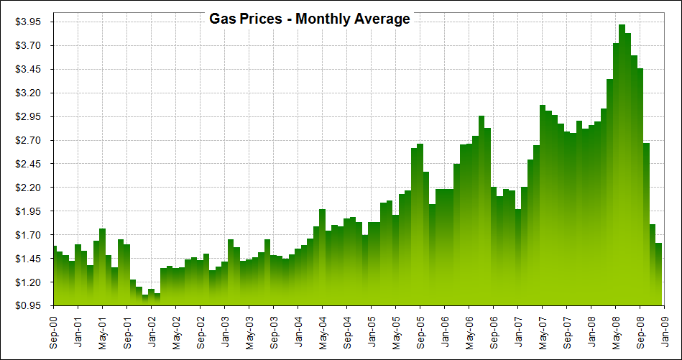  With traffic conditions steadily growing worse and the population ever increasing, anticipating continued high demand is very realistic. So expecting prices to return back to the way they were not too long ago is not wise. And along with the MPG benefit from a hybrid like Prius, you also get significantly reduced emissions.

NURTURING

Filling the Tank

 | Fill Speed | It is best to use the slowest setting (the farthest latch on the pump-handle); otherwise, the pump could shut off prematurely giving you an inaccurate indication of "full".
 | Topping Off | Don't! Once the pump automatically stops, don't trying squeezing any more fuel into the tank. More causes the bladder to stretch. Too much force will result in spitting out of fuel onto the ground. So never, ever pump more than 12 gallons.  Also, pumping too much fuel into the tank will result in gas filling up the vapor-capture canister. That defeats part of the emissions system. So if you want your Prius to remain the very cleanest possible, avoid ever doing this.  Important Note: As with all vehicles, repeated flooding of the vapor-capture canister cause damage to it… leading to eventual failure and required replacement.
 | 87 Octane Gas | Prius was designed to run with 87 Octane gasoline (85 in high altitudes). Several owners have experimented with 90 & 93 Octane; however, there wasn't any improvement to MPG. Since engine knocking is non-existent with Prius, there's no benefit in that respect either. Additionally, higher octane may trigger an emission sensor alert. Therefore, save some money by using 87 Octane.
 | Low-Sulfur Gas | Without the loss of performance or power, low sulfur gasoline helps to reduce emissions by preventing efficiency loss within the catalytic-converter (a pollution control device) due to sulfur build up. This also extends the life of the emission components. All gasoline sold in the United States was mandated to be low-sulfur beginning January 2006.
 | 10% Ethanol | 90% Gasoline blended with 10% Ethanol, better known as E10, will not harm any part of the Prius fuel or emission system. Owners in Minnesota, where E10 is mandated by law, have used this type of fuel in their Prius for many years without experiencing any problems at all. So there is no need for concern.
 | Empty | Don't ever run out of gas!  Not having the engine available makes driving a Prius using only electricity very risky. Without gasoline it is very easy to push the motor & battery-pack beyond the tolerances they were designed to operate. The battery-pack is never supposed to be fully depleted, that shortens its life. Also, without gas there's no way to prevent certain mechanical & electrical components (like the fuel pump) from overheating. Since Prius can go quite a bit further between fill-ups than most vehicles, there's really no reason you should ever run out of gas anyway. But if you do, drive very slowly and just enough far to get out of harm's way then stop. Don’t keep driving.
 | Another Gauge | When there is less than half a tank of gas remaining, the gas gauge is less accurate due to the flexible nature of the bladder within. A helpful measurement alternative is to base refill timing on the mileage you drive. Just reset one of the three odometers (A, B, or the one on the multi-display) every time you fill the tank.  400 miles (644 km) is a good distance to start with, in the summer. In the winter, distance can be reduced much more. You'll quickly figure out what works well for your own particular needs by watching how much it takes when refilling the tank.
 | Emission Bladder | Inside the gas tank is a flexible bladder. It contracts and expands to fill the empty void that would otherwise be filled with vapor as gasoline is consumed. The reduction of vapor emissions helps to keep Prius extraordinarily clean.  Overfilling should be avoided, since adding gas after the pump automatically stops can create pressure within the bladder. This could cause gas to be expelled afterward. So just don't top off.  Capacity reduces during the winter since cold temperatures cause the bladder to contract, up to 1.5 gallons (5.7 liters) in extreme conditions (below 0 F / -18 C degrees). That means you'll have to fill up sooner. But when temperatures are that dangerously low, you should really fill up at the halfway point anyway.
 | Gas Cap & Door | Twist the cap until it clicks. If it is not tightly secured, you may trigger an alert from the emission sensor. After all, Prius wouldn't be so clean if vapor were allowed to leak out. In the event of an alert, turn off the Prius and tighten the cap. Normal status should return after you restart.  Tuck the tether holding the cap to the car into the interior. Simply allowing it to be pushed by the door may cause a tangle making the door hard to open later.  Lubricate the hinge (WD-40 works really well). After extended exposure to dust, sand, and salt, the spring may struggle to open the door due to the hinge being dry.  Adjust the latch. It’s possible to accidentally bend it. Too much can make the door difficult to open. You may need to straighten it.

Multi-Display Care

 | Cleaning | The best way to remove fingerprints from the touch-screen is actually simpler that some owners realize. You don't need a special solvent or material. Just a plain old soft cotton fabric, like a well softened t-shirt or handkerchief. That’s it! But if must use a liquid too, try purified drinking water.  Also, make sure to only clean when the Multi-Display is off (or even better, the Prius itself is off). This will make the fingerprints easy to see and will prevent the "Reset" button from accidentally being pushed.

Long-Term Storing

 | Less than 3 Weeks | Nothing is needed, at room temperature. The engine should startup just fine. Be aware that this duration can be shortened by the age of the auxiliary-battery and the extreme cold.
 | More than 3 Weeks | If you have SKS (formally known as SS/SE), press the "SMART" button directly underneath the steering-wheel to disable it. The proximity detector actually only causes a continuous draw from that 12-volt auxiliary battery for the first 10 days of storage, then it automatically disables itself. But it is better to just do it yourself immediately.  If you have an alarm system, it is best to manually disconnect the 12-volt auxiliary battery passenger side in the hatch area. With it disconnected, that continuous drain will be eliminated. (Make note of the radio buttons you have programmed, since you'll need to manually restore them after reconnecting the 12-volt auxiliary battery.)  Draining the 201.6-volt battery-pack while in long-term storage is never a concern. When you shut off the Prius, an electric-relay automatically deactivates to cut the connection to the hybrid system. So it isn’t even connected to the rest of the system until you turn the key again.

Polishing

 | Owner Tests | "Nu Finish" is one of the longer lasting paint protective products that have worked well. If you’re looking for a glossy polish to get through an entire winter without reapplication, give that a try.

Tire Care

To prevent accelerated wear and maximize miles before replacement, follow these suggestions:

 | Monthly Checking | At the very least, check your tires monthly. Every two weeks is better. Pressure loss is normal and especially rapid when temperatures drop. Uneven wear is an indication that either you’ve been driving with tires below the minimum PSI or balancing/alignment is required. Also, don’t forget about checking the spare tire in the trunk too.
 | Front Bias | Prius is a little heavier in front. To properly support that weight load, you must make sure the front tires have 2 PSI more in them than the ones in the rear.
 | Turning | Never turn the wheels unless they're rolling. That causes unnecessary wear, just as with other vehicles. The electric-steering is so powerful, you can't feel the friction caused by turning. But your tires can. So, make sure the wheels are moving before you turn them.
 | Rotation | Every 5,000 to 7,500 miles (8,000 to 12,000 km) the tires should be rotated, for best lifetime performance. Rotation should be in a "roll-back, roll-forward" pattern. (That's swapping the front and rear tires without ever changing sides.)
 | Lug Nuts | When initially tightening the lug nuts after having put a wheel back on and when you re-torque them after having driven around 100 miles, make certain the pressure you use is 76 ft-lb (103Nm).
 | Alignment | 0.05 DEGREES of Toe IN each side, for a total of 0.10 DEGREES.  If steering feels like it wanders at high speeds, it's probably because the alignment isn't adjusted correctly. Remember, "within factory-specified tolerance" is an answer you don't have to accept from a service provider; you can insist that alignment be adjusted to this "exact" setting.
 | PSI minimum | 35/33 PSI (2.4/2.3 bar) is the PSI for the Prius tires (noted on the driver's door-jam of the car itself).  42/40 PSI (2.9/2.8 bar) is what many Prius owners recommend for optimum performance. For maximum performance, use a pressure of 44 PSI (3.0 bar). Whatever you decide, just remember that low pressure results in lower MPG drop and a shorter tire life.  Note 1: Measuring PSI should always be done when the tires are cold, since driving heats up tires making the results inaccurate due to the air inside expanding (which creates a false impression of higher pressure).  Note 2: For every 10 F degrees colder, pressure will naturally drop 1 PSI. The reverse is true too. So in the Spring, carefully monitor pressure to ensure it doesn't expand beyond the maximum as daily temperature increase.
 | PSI convenience | Tire pressure needs to be routinely checked (for all vehicles, not just Prius). Temperature drops cause PSI to decrease. Heat caused by driving increases PSI, making measurements inaccurate until cool. MPG & Safety are directly dependent on properly maintained PSI. Prius owners have found a way to make this simple: use a cordless inflator.  Cordless inflators (as shown to the right below) cost around $40. They are small & powerful, allowing you to increase PSI in the convenience & comfort of your own garage when the tires are still cool. As an added bonus, the battery in the cordless inflator can be used as a portable 12-volt power-supply to plug your automotive accessories into. Some even offer additional features, like a built-in light and even the ability to jump-start a vehicle.  Make sure to purchase a high-quality tire-gauge. For about $30 (as show to the left above), you’ll find that it is both easier to hold and easier to read than a less expensive one. That price will also deliver a 0.5 PSI accuracy that you can depend on for many years and a tough case to protect it.
  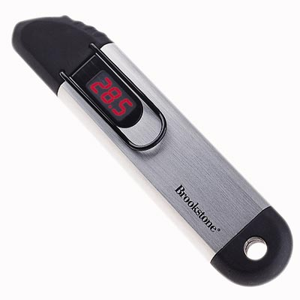 | 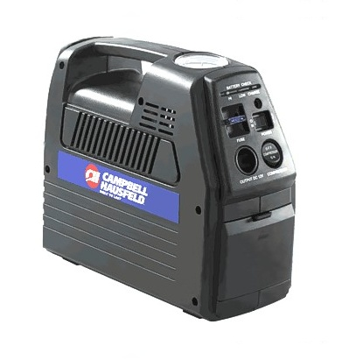

Tire Upgrades

Iconic Prius comes with standard, run-of-the-mill tires. In other words, they are fairly typical. So some owners are pleased with them and others choose to upgrade.

DISCLAIMER: The ideas, suggestions, and opinions offered here have not been endorsed by the manufacturer of those specific components or Toyota Motor Corporation. Any harm or damage that may result from the application of or the following of any ideas, suggestions, or opinions contained in this document is the sole responsibility of the individual that applied or followed said ideas, suggestions or opinions. The authors of this document hereby declare that they cannot and will not be held liable, in any fashion, for the content or the use of this information.

 | PSI | Iconic Prius is average weight, exactly what you'd expect a vehicle that size to weigh. It does not need special tires, since there is nothing extra to support. (In other words, XL rated tires are not required.)  Like with many vehicles, a minimum of 35 PSI (2.4 bar) is required for tire-pressure. Less than that will cause premature wear.  42/40 PSI (2.9/2.8 bar) is what many Prius owners recommend, since it increases the handling abilities and allows the tread to last its longest. (That's 42 front & 40 back, since a 2 PSI bias is required for the front tires.) The standard tires, as well as many other tires, support a maximum cold pressure of 44 PSI (3.0 bar). So using 42/40 is no big deal. In fact, some owners even use 44/42 PSI (3.0/2.9 bar).
 | LRR | Iconic Prius comes with standard tires. There are not LRR (Low Rolling Resistance), as many people believe. If you desire, you may switch to LRR tires. That will maximize MPG, offering a minor improvement over most standard tires.
 | Treadwear | 460 is the treadwear rating for the standard Iconic Prius tires. That's what many typical family vehicle tires come with. 800 is what you'll find on the ultra-long-life tires. So there is an obvious upgrade opportunity, if you want a set tires to last as long as possible.  The rating number represents the wear resistance of the tire. It does not correlate directly with the amount of mileage you'll be able to drive. Don't rely exclusively on this value when selecting a tire. Check the warranty, it will usually state an approximate distance expectation.
 | Revs | Revs (Revolutions per Mile) indicate the precise "rolling" size of the tire. This measurement is needed since not all tires with the same specification are actually the same.  855 is the Revs value for the standard Iconic Prius tires. When selecting an alternate, a number very close to that is required to insure the speedometer and odometer remain accurate. (Being off by a small amount is acceptable since that value will change as tread wears down anyway.)
 | Size | 185 / 65 R15 is the standard size tire for Iconic Prius. You'll find a wide variety of choices available for this size.  Wider sizes may also be used. But keep in mind that larger widths will reduce your traction on snow. A normal tire is better for digging through down to the road itself.
 | Original Tire | Goodyear Integrity  Iconic Prius comes with these tires standard. They are sometimes referred to as OEM (Original Equipment Manufacturer) tires.  185 / 65 R15  44 PSI (3.0 bar) maximum  1168 lbs. (530 kg) load maximum  Standard Rolling Resistance  855 Revs per mile  10/32 inch Tread-Depth  86S Speed & Load Rating  "A" Traction  "B" Temperature  460 Treadwear  50,000 (80,467 km) Mile Warranty
 | Upgrade Tire | Michelin HydroEdge  These are premium-grade, high-traction tires that can be used on a Iconic Prius.  Personal experiences with these tires are documented here... Hhttp://john1701a.com/prius/prius-maintain03.htm#TiresH
  185 / 65 R15  44 PSI (3.0 bar) maximum  1168 lbs. (530 kg) load maximum  Standard Rolling Resistance  856 Revs per mile  11/32 inch Tread-Depth  86T Speed & Load Rating  "A" Traction  "B" Temperature  800 Treadwear  90,000 (144,841km) Mile Warranty | 
 | Upgrade Tire | Goodyear TripleTred  These are premium-grade, high-traction tires that can be used on a Iconic Prius. (Unfortunately, they are not available in the standard size. So you have to use an alternate instead.)
  195 / 60 R 15  44 PSI (3.0 bar) maximum  1190 lbs. (540 kg) load maximum  Standard Rolling Resistance  863 Revs per mile  11/32 inch Tread-Depth  86H Speed & Load Rating  "A" Traction  "B" Temperature  740 Treadwear  80,000 (128,748 km) Mile Warranty | 

 | Upgrade Tire | Michelin Harmony  185 / 65 R15  44 PSI (3.0 bar) maximum  1168 lbs. (530 kg) load maximum  Standard Rolling Resistance  848 Revs per mile  11/32 inch Tread-Depth  86S Speed & Load Rating  "A" Traction  "B" Temperature  740 Treadwear  80,000 (128,748 km) Mile Warranty
 | Upgrade Tire | Goodyear ComforTred  185 / 65 R15  44 PSI (3.0 bar) maximum  1168 lbs. (530 kg) load maximum  Standard Rolling Resistance  855 Revs per mile  11/32 inch Tread-Depth  86T Speed & Load Rating  "A" Traction  "B" Temperature  700 Treadwear  80,000 (128,748 km) Mile Warranty

Washing

 | Antenna | Removing the antenna is easy; just unscrew it (counter-clockwise). Then you don't have to worry about it while going through an automatic car wash.

Valet Use

 | Valet Card | Providing the valet with a "Valet Card" Toyota includes with the purchase of a new Prius is highly recommended. It illustrates how to start the hybrid system in very simple steps.
 | Engine On | Stealth can confuse valet drivers, since they expect noise & vibration rather than dead silence. Keeping the engine running could prevent a mishap. Valets may repeatedly try to start the Prius not realizing it's already running. Or worse, they may get out while the Prius is still in "D" (Drive) because they think it’s off. To minimize this risk, set the defroster to the maximum cold or hot setting. This forces the engine to continue running.

Grille Blocking

Efficiency & Emissions are both dependent upon warmth. During the winter, colder temperatures require the engine to run more to provide that. By blocking the grilles, warmth can be retained longer. With less cold air hitting the radiator and passing through to the engine compartment (along with an accompanying aerodynamic improvement), the overall amount of fuel consumed can be reduced.

 | Discreet Look | 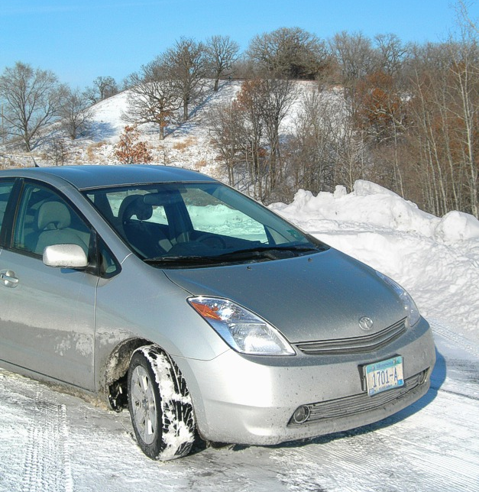 | Unless you’re specifically looking for it, you may not even notice the upper-grille is blocked entirely and the lower-grille partially.
 | Blocking Method | There are a variety of different methods available for grille blocking, some more cosmetically appealing than others. Squeezing half-inch foam pipe insolation between each grille slot is a quick and inexpensive method that works surprisingly well. The only tool you need is a knife to cut notches in a few places to allow the foam to insert flat. The tight fit holds the foam in place.  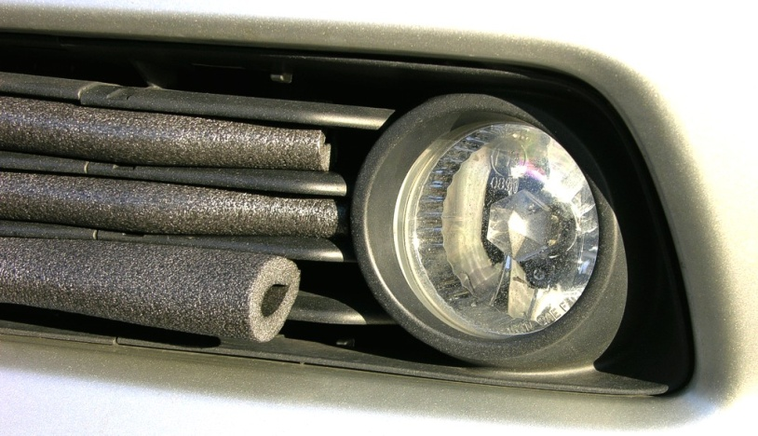
 | Partial Blocking | Once the daytime high temperature in your area drops below 50 F degrees (10 C), it is safe to block the upper-grille entirely and the lower-grille partially.
 | Full Blocking | For those experiencing in harsh climates, such as Minnesota, there can be a benefit from blocking the lower-griller entirely. You’ll want to monitor temperature of the coolant though. Also, note that outside temperature won’t be displayed correctly, since that will inhibit the sensor.
 | Temperature | Use an aftermarket add-on device, like ScanGaugeII, to monitor the engine coolant temperature. The normal operating range of 186 F to 194 F degrees (85.5 C to 90 C) is what to expect. At about 204 F degrees (95.5 C) the radiator fan will turn on. Above that is when you should be concerned. The heater will trigger the engine to restart at 145 F degrees (62.8 C).

MAINTENANCE

Oil Changes

 | Efficiency | Refer to the "Increasing MPG "section.
 | 5,000 Miles or  6 Months | 5,000 miles (8,000 km) or 6 months, whichever comes first.  Having the engine shut off frequently and not using it as the sole propulsion source will allow oil to last longer than in traditional vehicles. It simply isn't exposed to the strenuous engine conditions found with. Nonetheless, it is still important to routinely change the oil & oil-filter.
 | Reminder Light | After 4,500 miles (7,250 km), an indicator light will flash for 12 seconds after starting, then it will turn off.  After 5,000 miles (8,000 km), an indicator light will flash for 12 seconds after starting, then it will change to a steady glow and remain on.  If you change the oil (and filter) yourself, here's how to reset the light so it will stay off until the next change is interval has expired:  - With the power on, switch to the odometer/trip-meter to display "ODO".  - Power OFF (push the "Power" button).  - Power ON, while holding the button for "ODO".  - Wait for the reminder light to stop flashing, then release.  While the reset is taking place, you'll see the odometer value change to 5 dashes. Then each will be disappear, one at a time from the left. When finished, 7 zeroes will briefly appear, indicating the process is complete before the previous odometer mileage returns.
 | Illustrated Detail | 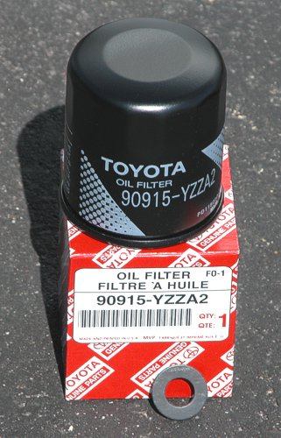  Oil Filter Toyota Part: 90915 - YZZF2  or: 90915 - YZZA2  Plug Gasket Toyota Part: 90430 - 12028  (approximate combined cost: $8.50)  http://john1701a.com/prius/prius_oil-change.htm  That link above is for a document with many photos, which provides details about the oil-change process for a Prius. Download a copy to see the underneath of the vehicle along with the components involved and the supplies you'll need to perform an oil-change yourself.
 | Overfilling | This is an unfortunate reality that far too much owners have to face. Oil pumped from bulk barrels into your engine is commonly not carefully measured by dealers and quick oil-change places. So make sure to check the level yourself after the service is complete. If the oil-level is beyond "full", insist that they remove the excess.  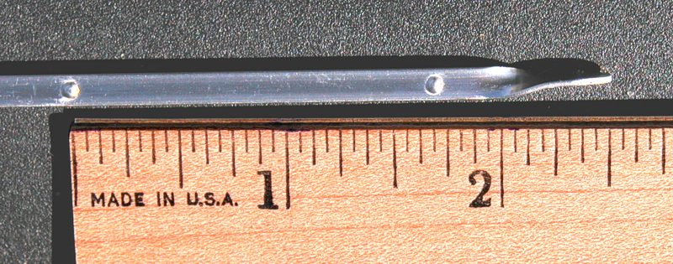  The ideal level is 1/4” (one-quarter inch or 6 millimeters) below the "full" mark, which is between the D and the E on the photo above.  Too much oil causes MPG to be reduced. Way too much oil causes damage to the engine. So it is in your best interest to make sure the oil-level never goes above the "full" marker on the dipstick. 3.9 quarts (3.7 liters) is the maximum capacity, so there is no need to ever use that much. Never pour in more than 3.5 quarts (3.3 liters). Even less is better. It's easy to add more afterward. Removing too much is very, very difficult.  A simple way to avoid overfilling problems is to provide your own oil (which is common for those preferring synthetic anyway) instead. They'll just deduct the price difference from your bill. Only supplying the mechanic with the correct amount will guarantee they won't overfill.

Engine Air-Filter

 | Access | The 4 yellow ellipses in the photo indicate the location of the clips holding the cover for the engine air-filter in place. Unlatch them, then lift the cover until the hinges in back release their hold on it.  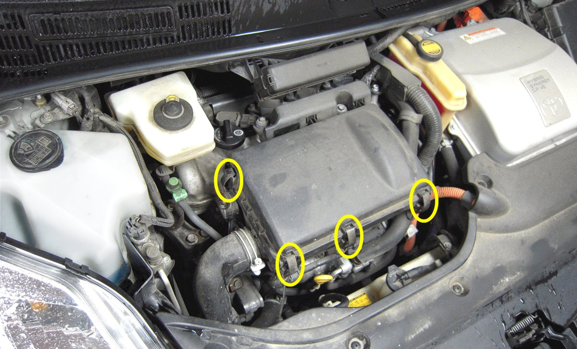
With the cover removed and placed over to the right, you can see the top (clean side) of replaceable air-filter over the engine and the secondary permanent filter bonded to the cover itself.

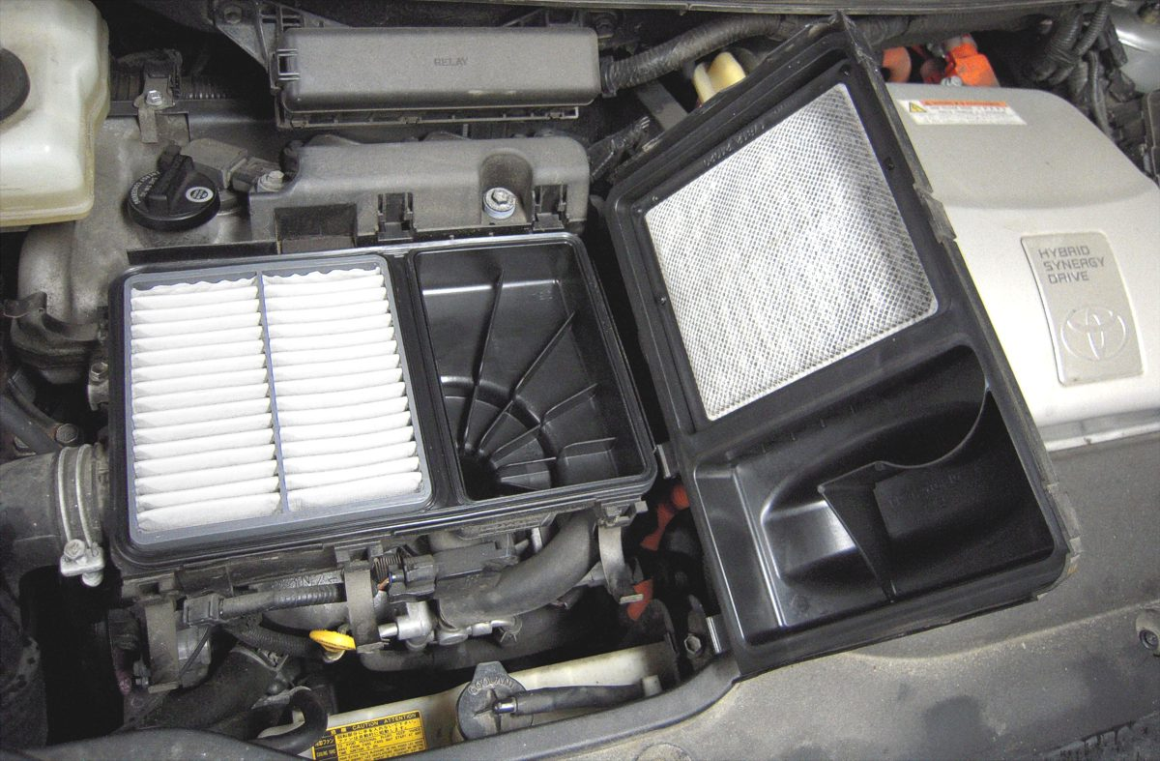

The underside of the engine air-filter is where dirt, bugs, and leaf particles are trapped. If there is excessive build up, replace it. (Note: The rubber gasket attached is included with the new filter.)

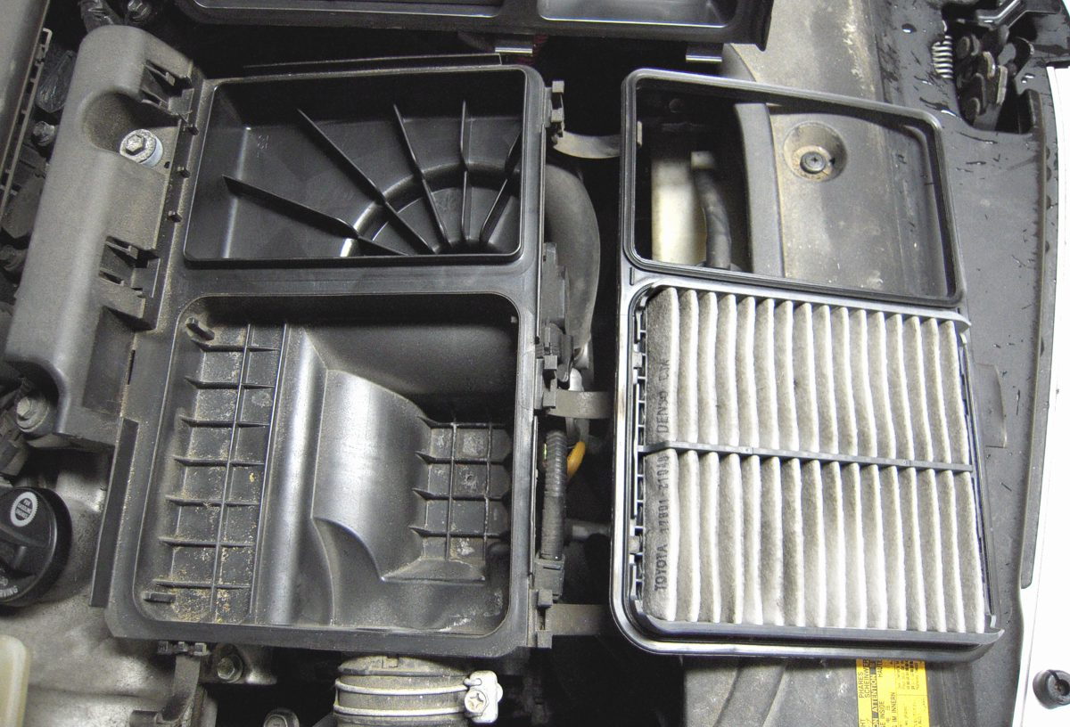

 | Replacement | Replacement every 30,000 miles (about 48,000 km) is recommended. But you’ll want to check it sooner, especially if routinely you drive through areas with a lot of dust. The more restricted air flow becomes, the greater the negative impact on engine efficiency.  Toyota Part: 17801 - 21040 (approximate cost: $18.00)

Window Wipers

 | Front Blades | 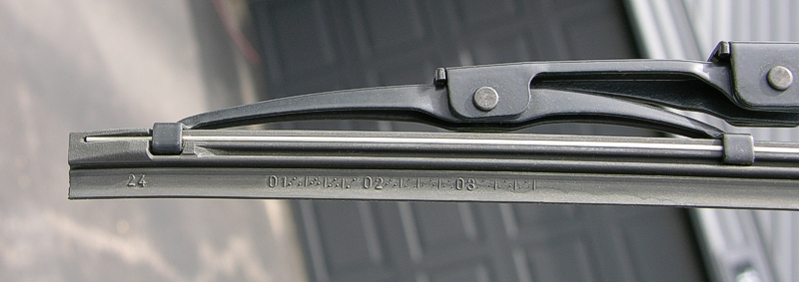  Replacing the two wiper blades in the front is surprisingly easy. You don’t even have to remove the wiper assembly from the car (though you can, if you want). About every 30,000 miles or so (about 48,000 km) it will become necessary.  Just carefully squeeze the rubber at the far left (shown above) and pull inward a little bit. It will bend just enough to allow you to slide it out of the clamp (shown below). With that unsecured, the remainder of the wiper blade can be removed entirely just by pulling on it lightly, since none of the other clamps lock it in place.  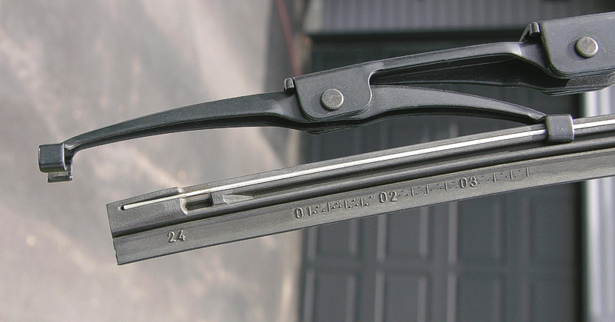  Hhttp://john1701a.com/prius/prius-wiperblades.htmH ...provides details (and more photos) of the replacement process for both the front & reap wiper blades.  Front Driver Wiper Toyota Part: 85124 - 46010  Front Passenger Wiper Toyota Part: 85124 - 47010  (approximate combined cost for all 3 wiper blades: $23.50)
 | Rear Blade | To pivot the wiper arm upward, all you have to do is remove the clamp. It is the 2.5 inch (6 cm) piece of flexible plastic at the base, where it connects to the window. Just pull both sides out and slide it toward you. With that plastic off, the access to the blade is now possible. You can lift the arm up to get at the underside of it.  This photo shows that plastic clamp removed (the black object in the lower-right corner) and the arm of the rear wiper lifted up.  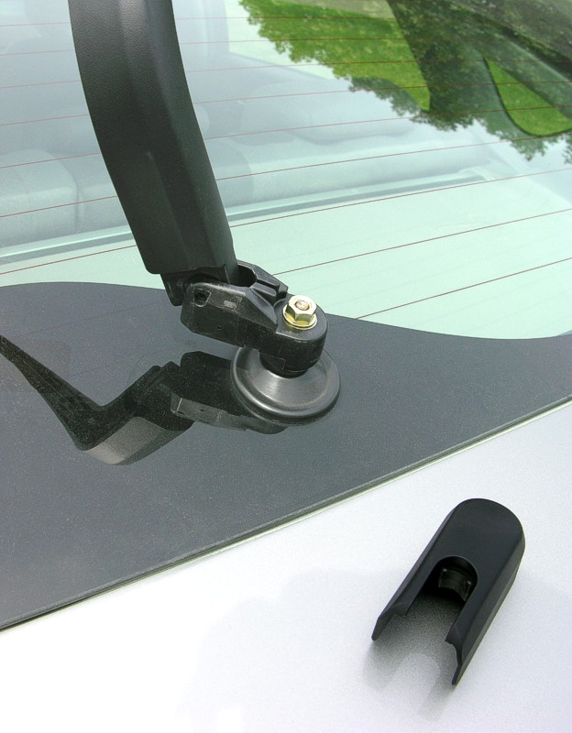  Rear Hatch Wiper Toyota Part: 85124 - 44140

Fuel Door

 | Lubricate | After a long enough duration, it will eventually become difficult to open. Exposure to sand, salt, moisture simply causes the existing lubrication to be less effective. Just a few squirts of WD-40 is all it takes to maintain/restore easy opening.  If you do discover that it is jammed shut, just recruit someone to help (since the distance between is too great for one person). Lifting the lever by the driver’s seat and pushing on the back (left side) of the fuel door at the same time will dislodge it. There’s no need for any type of tool; very little pressure is required.

Air-Conditioning

 | Filter Access | There is a Hepa filter for the Air-Conditioning system directly behind the glove-box, which can be changed without tools. Every 30,000 miles or so (around 48,000 km) replacement will be needed.  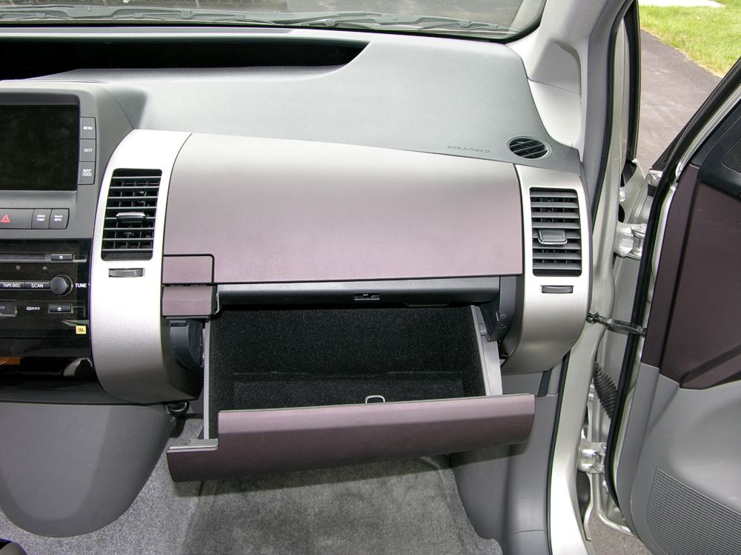  Open the bottom glove-box, and then remove all the contents (since they will end up falling out all over the floor otherwise).  To the right of glove-box is an attached small plastic hydraulic arm (to add a resistance feel). Pull on that arm so it separates itself from the glove-box. Then hold onto the left and right sides of the glove-box while squeezing inwards. This will allow you to pull the glove-box downward, beyond the usual stopping point. Having accomplished that, you may let go. Just let it hang there, like this:  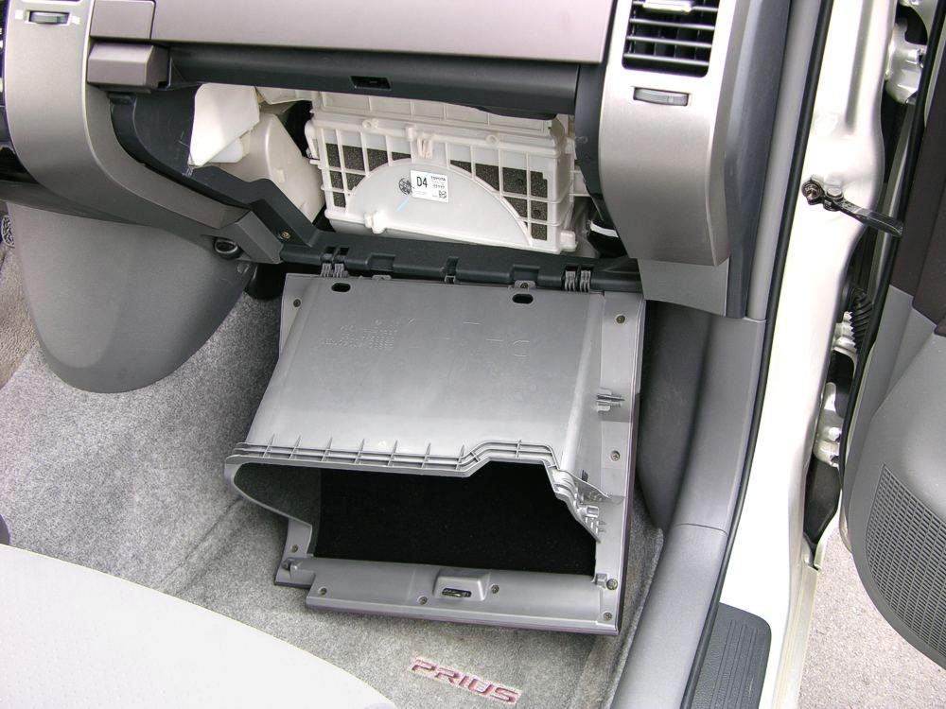  The air-flow assembling will then be completely visible and very easy to access. You’ll see the filter at the top, lying horizontal along the entire width of that white plastic air-duct. Just pull on both sides to slide it out. Then you can easily inspect it and replace it (when needed).  For detail and more illustrations, refer to Hhttp://john1701a.com/prius/prius-airconditioner-filter.htm  Toyota Part: 87139 - 47010 (approximate cost: $25.50)

Light Bulbs

 | Hatch Replacement | There are 2 light bulbs which illuminate the license plate in back, as shown to the right.  If either needs to be replaced, they are accessible from the vehicle interior.  Toyota Part: 00234 - 00192  (approximate cost: $1.70 each) |  | 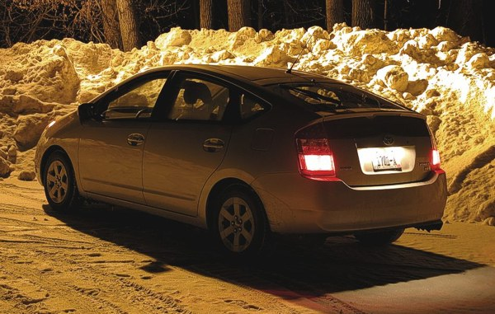
 | Hatch Replacement | 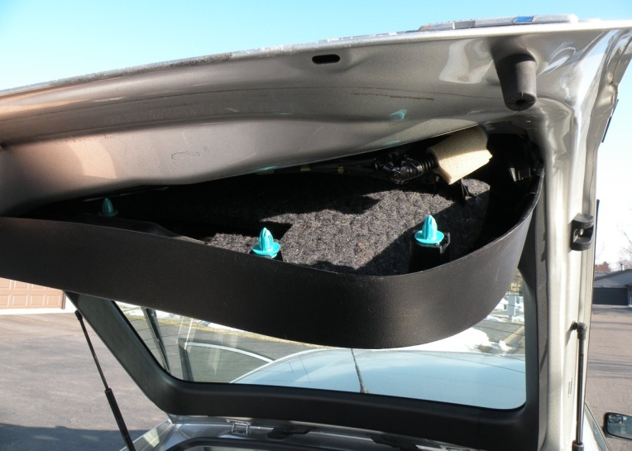 |  |  |  |  | With the hatch open, pry the hatch cover away from the metal. It’s held in place by aqua colored plastic clips.  You can exert a surprising amount of pressure without worry of breaking it.
 | Hatch Replacement | This is what the hatch cover looks like removed.  Notice the position of those plastic clips and the location of the internal handle. | 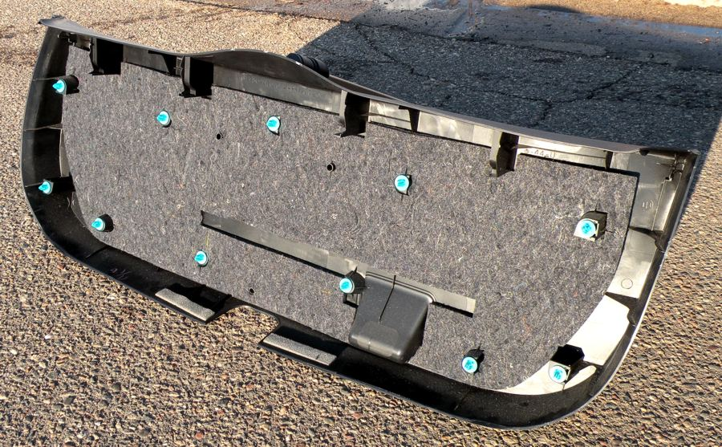
 | Hatch Replacement | 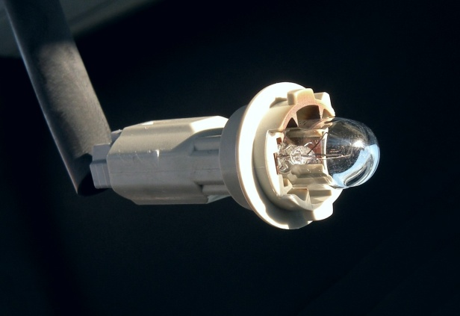 |  |  | This is what you will be disconnecting from the hatch itself. It is a socket for the bulb attached to an electrical wire.
 | Hatch Replacement | There are openings in the metal hatch door you just exposed, one for each license bulb.  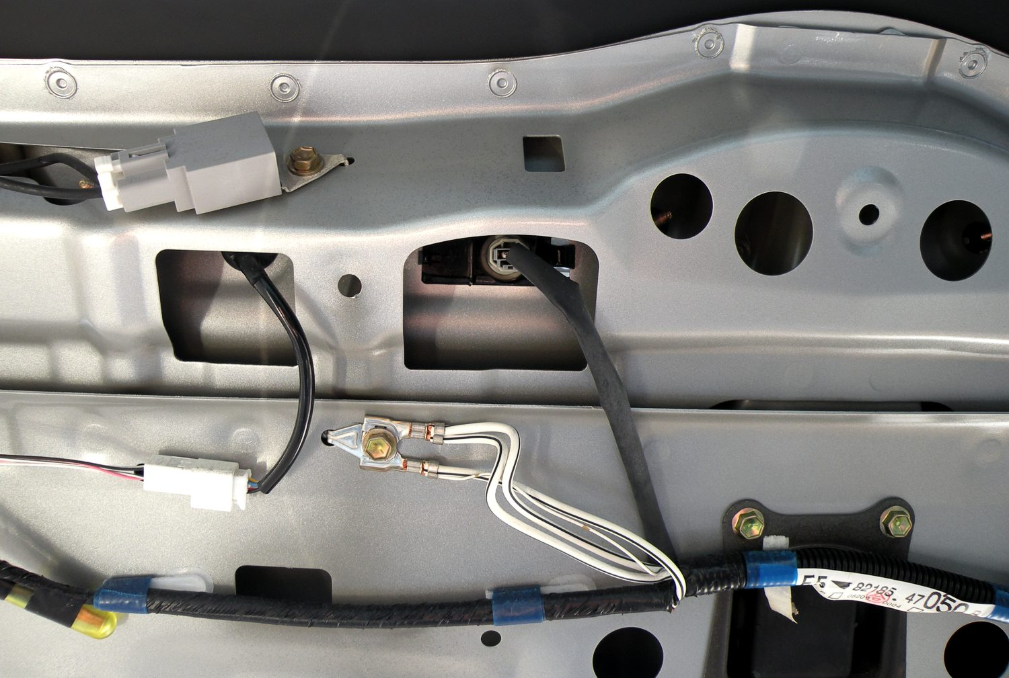
 | Hatch Replacement | 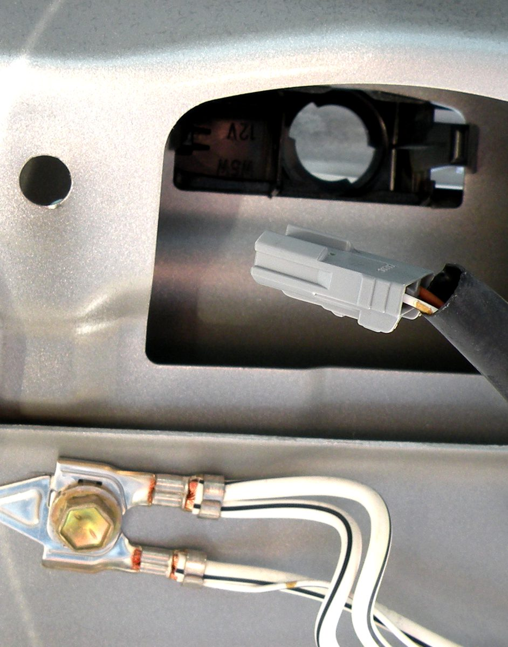 |  |  |  | Rotate the entire assembly in a counter-clockwise direction. If it is really tight, use a pliers for better grip.  To the left is a close-up of the area where the license bulb was. That gray object is the harness.  Below is the light socket that was attached to the harness. It is the white object and detaches by sliding off. The glass bulb pulls out of it.  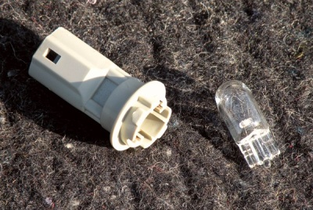

OPTIONS

SKS: Smart-Entry

It is proximity detection system that automatically senses a wireless transmitter (called a "FOB") in your pocket or purse, allowing you to unlock the doors & hatch without the need to use a physical key or push a button on a remote.

 | Touchless Unlock | Reaching into the handle area on the outside of the Driver's door, you'll trigger the sensor to unlock just that door.  Reaching into the handle area on the outside of the Passenger's door, you'll trigger the sensor to unlock all the doors.  Reaching into the handle area on the outside of the Hatch door, you'll trigger the sensor to unlock the all the doors as well as the hatch.
 | Automatic Disable | Leaving the FOB inserted into the dashboard-slot for more than 10 minutes after power OFF will cause the SKS to be disabled. To enable it again, press the button under the steering-wheel.
 | Manual Disable | Look for a button labeled "SMART" on the dashboard directly underneath the steering-wheel. Pushing that will toggle between disable & enable. As the 12-volt auxiliary battery ages, constant trickle drains from it for extended durations (especially during the winter) should be avoided. So if you are going to leave your Prius sit for several weeks, the disable will help you get the longest life from the battery. Note that the battery-pack, not the auxiliary, is what supplies power for starting the engine.  Another use for that "SMART" button is to simply prevent the wireless functionality, should you have the need for direct-contact only operation.
 | Outside Locking | On both front door handles and the hatch in back, there are small black buttons. Pushing one of them will trigger a beep and flash the lights to inform you the SKS (formally known as SE/SS) system has just locked the Prius. This ability prevents the need for you to ever touch the SKS device in your pocket or purse… unless you need to use the "panic" button on the back (which honks the horn and flashes the lights).

SKS: Smart-Start

It is proximity detection system that automatically senses a wireless transmitter (called a "FOB") in your pocket or purse, allowing you to start the hybrid system without the need to use a physical key or push a button on a remote.

 | Power Button | No more squeeze & rotate. For that matter, there is no key anymore either. Once you are in the vehicle and the wireless connection is automatically made (or the FOB is inserted into the slot in the dashboard), it’s just a matter of stepping on the brake and pushing the power button.  You’ll find this popular feature a very convenient improvement over the traditional method for starting a vehicle.  It’s how you shutdown afterward too. Just push the button.

SKS: FOB Battery

The battery within the FOB has been lasting between 4 to 5 years for the typical owner with SKS. Without the wireless feature, it is expected to last even longer.

 | Status Check | Press any button on the FOB. If the red miniature indicator-light in the upper-right corner does not illuminate, the battery charge-level has grown low. Replacement should then be considered.  When shutting down the vehicle, a beep will sound immediately after pushing the power button. This also indicates that battery replacement time is near.
 | Dead Battery | If the battery is completely drained of power:  - Use the key hidden within the FOB to unlock the driver’s door.  - Insert the FOB into the dashboard slot to start the vehicle directly.
 | Battery Details | CR-2032 is the battery type to purchase.  $3.50 is approximately how much it will cost.
 | Change Info | This series of photos illustrate the protective-door removed, the battery-cover unscrewed, and the indicator light. The only tool you will need is a jeweler’s screwdriver. After removing the key, continue to hold the latch and firmly push with your thumb behind the emblem to slide it off.
 | Change Info | 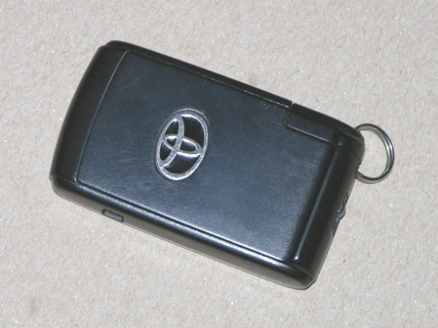 | 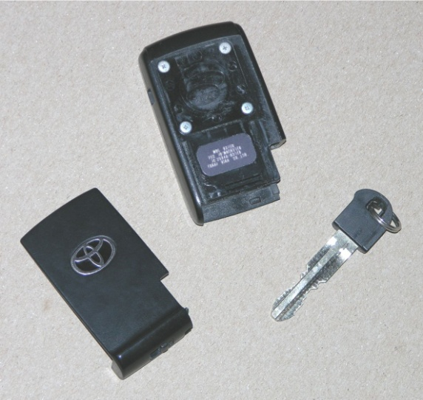
 | Change Info | 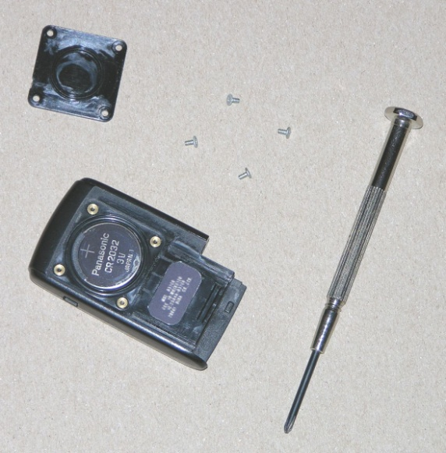 | 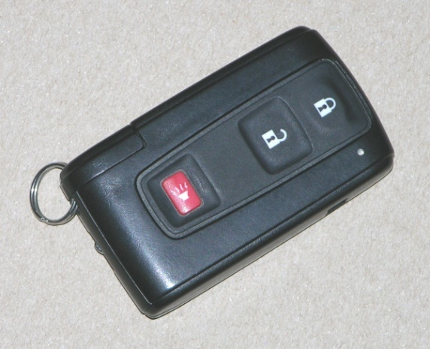

Homelink

It is a set of buttons on the rear-view mirror available for custom programming, to supplement your other remotes.

 | Garage Door | To program a Homelink button on your mirror to open & close your garage-door, do the following:  - If the mirror is off, turn it on. (The indicator light will be a steady green.)  - Press the desired programmable-button (the left most three) on the mirror and continue holding it depressed throughout the entire programming process.  - With the garage-door remote held close to the mirror, press the button on it repeatedly.  - When the indicator light on the mirror changes to a rapid blinking red, stop pressing both the buttons on the mirror and the opener. Programming is complete.  - Test the newly programmed Homelink button. Pressing it for 1 second will change the indicator light from a steady green to a steady red, which will instruct your garage door to open or close just like your garage-door remote.  * Note: this programming is only available for remotes with non-rolling security codes.

Electrochromic Mirror

 | Making it Darker | Some owners have discovered that the automatic dimming mirror doesn’t get dark enough for them at night. The solution to this high-tech problem is a surprisingly low-tech modification. All you have to do is trick the mirror into thinking it is darker outside by just covering the optical-sensor on the back with a piece of transparent plastic. That way, less light is detected. The response is a deeper shade of green, which makes the headlights behind you appear less intense.  This photo shows how the optical-sensor has been covered by a piece of blue transparent plastic, attached to the mirror using a piece of clear adhesive tape.  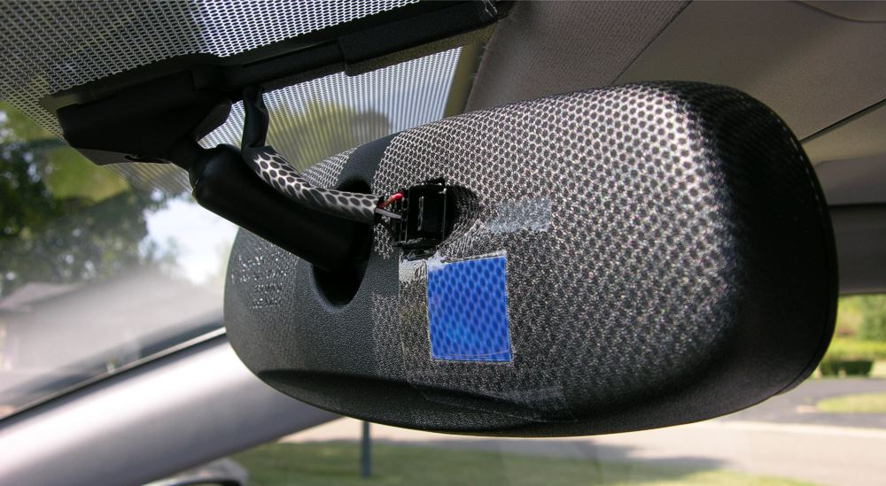

Navigation

 | Adaptive Volume | Increases the volume of the Navigation System's guidance information when going over 50 MPH (80 km/h).
 | Mark Button | When you get to a common destination or one that was particularly difficult to find, take advantage of the "Mark" button on the Multi-Display (only visible when you have the extended menu shown). That will add it to the "Memory Points" menu. Up to 106 locations can be stored, so take advantage of this to make future navigation destination selection easier.

Bluetooth

 | Phone Type | Here's a sampling of the some oldest Bluetooth-enabled phones stated to work with Prius:  Motorola: V330, V505, V551, V600, V710, RAZR-V3  Nokia: N-Gage, 3600, 3620, 3650, 3660, 6230, 6310i, 6600, 6620, 6820, 7610, N-GAGE QD  Sony Ericsson: T68i, T608, T610, T616, T637, Z600, SX1, S55, S56, W600i  Since the introduction of the Iconic Prius, many more cell-phones were added to the Bluetooth list.  Check with your local provider for compatibility information. You may also find helpful facts on this webpage... Hhttp://toyota.letstalk.com/bluetooth/bt_userguides.htm
 | Adding a Phone | Here's abbreviated instructions for setting up the RAZR-V3:  - On the Prius Multi-Display, select "Telephone", "Settings", "Add Phone"  - On the phone, select "Settings", "Connectivity", "Bluetooth Link", "Handsfree", "Look For Devices", "HANDS FREE", "Yes"  - Enter the password/passkey "1212" when prompted.  - Setup should then be complete, confirmed by a connect message.
 | Handoff | Some Bluetooth-enabled phones will allow you to transfer an active call from the connected device back to the phone itself, which is very convenient if you’ve arrived at your destination and do not wish to remain in the car. That handoff is surprisingly simple too. Just push the "Power" button on the Prius. The phone should then prompt you with a continuation question. Respond with a "Yes".
 | Volume | While a call is active and the Multi-Display is showing the volume control, you can adjust the level by pressing the up & down buttons on the steering-wheel the very same way you’d adjust the radio.
 | More Info | Refer to Hhttp://john1701a.com/prius/prius-bluetooth.htm

Voice-Recognition

 | No Training | There is no training process for all the commands. The voice-recognition is remarkably adept the way it comes installed, so you can use it immediately.

VOICE-RECOGNITION

Help

Command Help
Command List
Help

Navigation - Commands

 | I'm Hungry  POI Off  Route Overview  Compass Mode  Heading Up  North Up  Louder  Softer  Repeat  Repeat Voice  Cancel  No  Yes  Short  Mark  Mark This Point  Zoom In  Zoom Out  Lexus Dealer  Lexus Dealership  Toyota Dealer  Toyota Dealership  Previous Start Point  Previous Starting Point  Right Map Direction  Right Map Heading Up  Right Map North Up  Right Map Zoom In  Right Map Zoom Out | Add to Destination  Cancel All Destinations  Cancel Final Destination  Cancel Next Destination  Delete All Destinations  Delete Final Destination  Delete Next Destination  Enter Destination  Previous Destination  Replace Destination  Arrow Guidance  Arrow Guide  Freeway Guidance  Freeway Guide  Guidance Screen on Freeway  Intersection Guidance  Intersection Guide  Lane Guidance  Repeat Guidance  Resume Guidance  Start Guidance  Stop Guidance  Suspend Guidance  Turn List Guidance  Turn List Guide  Dual Map  Entire Route  Entire Route Map  Fifth Destination Map  Final Destination Map  First Destination Map  Fourth Destination Map  Map  Map Direction  Next Destination Map  Second Destination Map  Single Map  Third Destination Map | Change to Arrow Guidance  Change to Arrow Guide  Change to Compass Mode  Change to Dual Map  Change to Freeway Guidance  Change to Freeway Guide  Change to Heading Up  Change to Intersection Guidance  Change to Intersection Guide  Change to Lane Guidance  Change to Map Direction  Change to North Up  Change to Single Map  Change to Turn List Guidance  Change to Turn List Guide  Go to Previous Destination  Go to Quick Access 1  Go to Quick Access 2  Go to Quick Access 3  Go to Quick Access 4  Go to Quick Access 5  Go to Quick Access Number 1  Go to Quick Access Number 2  Go to Quick Access Number 3  Go to Quick Access Number 4  Go to Quick Access Number 5  Go to Start Point  Go to Starting Point  Quick  Quick 1  Quick 2  Quick Access 1  Quick Access 2  Quick Access 3  Quick Access 4  Quick Access 5  Quick Access Number 1  Quick Access Number 2  Quick Access Number 3  Quick Access Number 4  Quick Access Number 5

Navigation - Locations

 | Airport  American Food  American Restaurant  Amusement Park  ATM  Auto Club  Auto Service  Auto Service and Maintenance  Automobile Club  Bank  Barber Shops  Beauty and Barber Shops  Botanical Garden  Bus Station  Business Facility  Campground  Car Wash  Casino  Chinese Food  Chinese Restaurant  Cinema  City Center  City Hall  Civic Center  Coffee House  College  Community Center  Commuter Rail Station  Continental Food  Continental Restaurant  Convenience Store  Convention Center  Court House  Current Location  Current Position  Department Store  Detour  Detour Entire Route  Dry Cleaning  Exhibition Center | Fast Food  Ferry Terminal  Fitness Club  French Food  French Restaurant  Gas  Gas Station  Go Home  Golf  Golf Course  Government Offices  Grocery Store  Health and Fitness Club  Higher Education  Historical Monument  Home  Home and Garden  Horse Racing  Hospital  Hotel  Ice Cream Parlor  Italian Food  Italian Restaurant  Japanese Food  Japanese Restaurant  Library  Marina  Mexican Food  Mexican Restaurant  Museum  National and State Parks  National Parks  Other Automotive  Other Automotive Stores  Other Business  Other Business Facilities  Other Financial  Other Financial Services  Other Food  Other Restaurant | Other Retail  Other Retail Stores  Park  Park and Recreation  Parking  Parking Garage  Parking Lot  Performing Arts  Pharmacy  Police Station  Post Office  Rental Car  Rental Car Agency  Rest Area  Rest Stop  Restaurant  School  Seafood  Seafood Restaurant  Service and Maintenance  Shopping  Shopping Mall  Ski Resort  Skiing  Specialty Food  Specialty Food Store  Speedway  Sports Complex  Stadium  Thai  Theater  Tourist Attraction  Tourist Information  Train Station  Triple A  University  Video Rental  Winery  Zoo  Zoological Garden

Audio

 | Audio  Audio On  Audio Off  Radio  AM  AM Radio  FM  FM Radio  FM1  FM2  Program  Seek Down  Seek Up | CD  CD Changer  Disc Down  Disc Up  Next Disc  Next Track  Previous Disc  Previous Track  Skip Backward  Track Down  Track Up | SAT  SAT1  SAT2  SAT3  Satellite Radio  Satellite Radio 1  Satellite Radio 2  Satellite Radio 3  Type Down  Type Up  Cassette  Tape  Fast Forward  Play  Reverse  Rewind

Climate

 | Automatic Air-Conditioning  Automatic Air-Conditioning Off  Automatic Air-Conditioning On  Cooler  Warmer  Lower Temperature  Raise Temperature | Temperature 65 Degrees  Temperature 66 Degrees  Temperature 67 Degrees  Temperature 68 Degrees  Temperature 69 Degrees  Temperature 70 Degrees  Temperature 71 Degrees  Temperature 72 Degrees  Temperature 73 Degrees  Temperature 74 Degrees  Temperature 75 Degrees  Temperature 76 Degrees  Temperature 77 Degrees  Temperature 78 Degrees  Temperature 79 Degrees  Temperature 80 Degrees  Temperature 81 Degrees  Temperature 82 Degrees  Temperature 83 Degrees  Temperature 84 Degrees  Temperature 85 Degrees | 65 Degrees  66 Degrees  67 Degrees  68 Degrees  69 Degrees  70 Degrees  71 Degrees  72 Degrees  73 Degrees  74 Degrees  75 Degrees  76 Degrees  77 Degrees  78 Degrees  79 Degrees  80 Degrees  81 Degrees  82 Degrees  83 Degrees  84 Degrees  85 Degrees

Screen

Screen Off

OTHER

Battery-Pack

 | Replacement | The power management system was designed to maximize battery life. It rigorously works to always keep the charge-level at optimum, by never fully draining or fully recharging it. And you can clearly see that by watching the indicator on the Multi-Display. Lab testing has demonstrated that the battery-pack will last an equivalent of 180,000 miles (290,000 km) of driving without any deterioration. And the preliminary real-world data now available is confirming those findings. The battery-pack is expected to last the lifetime of the vehicle. With normal wear & tear, Prius owners should not expect to ever have to replacement it. (The US distance record as of March 2008 from a Classic model Prius was an amazing 349,531 miles!)
 | Recycling | Toyota has had a recycling program in place for NiMH batteries ever since the electric version of the RAV4 was introduced back in 1998. Every part of the battery, from the environmentally safe precious metals to the plastic, plates, steel-case, and the wiring, can all be recycled. To ensure that the battery-packs come back to Toyota, each battery has a phone number on it to call for recycling information and dealers are paid a "bounty" of $200 for each pack collected.

Rear Hatch

 | Slam It! | The hatch door is designed to be slammed shut. So if you find you are not getting it to shut tight, don't feel afraid to use some muscle on it. Holding back isn't necessary. Grab the hand-hole (that cavity within the plastic, on the right as you face it) then... Slam It! Damn It!
 | Unlock | SKS (formally known as SE/SS) won't unlock the hatch while the Prius is running. So to unlock the hatch, you need to press the unlock button on the inside either of the front doors.
 | Extra Height | Temporarily remove the false floor to reveal the hidden storage area. Doing that provides an extra 6 inches of height from the glass, for carrying unusually tall cargo.
 | Cargo Cover | The rollout "shade" that is used to cover the hatch (to conceal the contents, if any) uses plastic grips that lock into place with the body of the car. Each grip attaches to the cover using 2 screws. It is possible, after plenty of use, for a screw to come loose and eventually fall out. Don't let the inconvenience occur. Be proactive by either tightening them annually (like during routine spring cleaning) or take the time to make the connection permanent by sealing over the screw with a heat-resistant adhesive (like “Super Goo”).
 | Securing Cargo | There are 4 metal-rings, bolted to the frame of the vehicle, available for securing cargo. Each is located in a corner of the hatch area. Use them in conjunction with bungee-cords or rope to keep large or loose items from shifting while you drive. If you need addition locations when the back seats are up, simply raising a headrest to reveal metal rods that can be used. When the back seats are folded down, you may use the latch-loop that is normally used to secure the seat in place.
 | Cargo Nets | There are two types available. One mounted flat (horizontal) across the floor, connecting to each of the metal-rings. You just slip cargo underneath it to prevent movement while you drive. The other is mounted upright (vertical), connecting to the 2 metal-rings closest to the hatch door and 2 connector-points which you add by drilling a simple hole in a location close to the window. This type works well for cargo such as grocery bags.
 | Hidden Release | From inside the hidden storage area underneath the floorboard, remove the tiny black panel on the side closest to the hatch, and then poke your finger through that hole into the metal casing. There's a smooth tiny metal latch there. (Toyota definitely wanted to make that inaccessible from outside.) Pulling it up pops the hatch open.  With the hidden storage area removed, the photo below shows the exact location of that metal latch, as indicated by the yellow “ V ” mark.  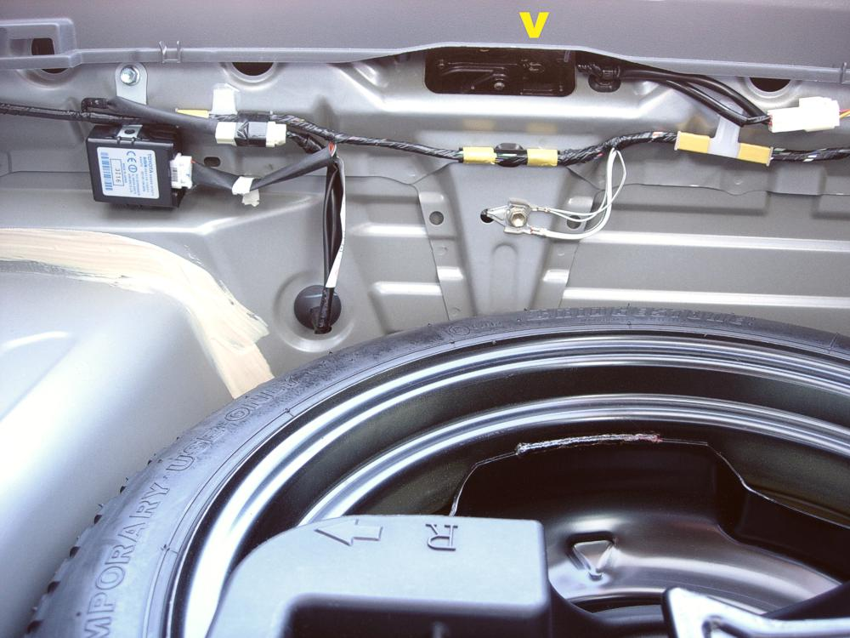  The following close-up of the photo above makes that metal latch (brass colored) easier to see, again as indicated by the yellow “ V ” mark.  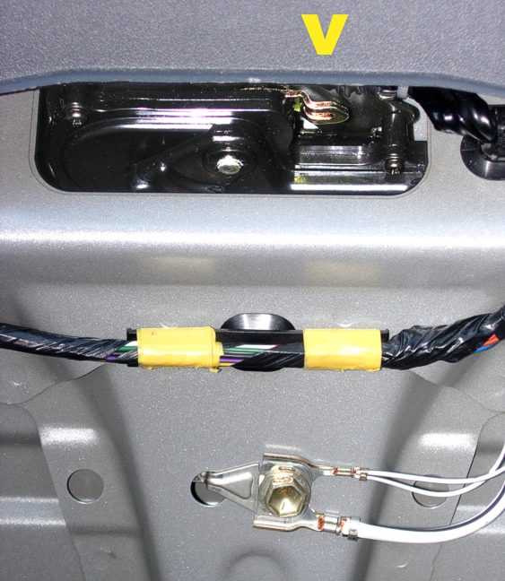
 | Height Reduction | For those of you that don’t want to reach so high to close the hatch, try this alteration:
 | Height Reduction | 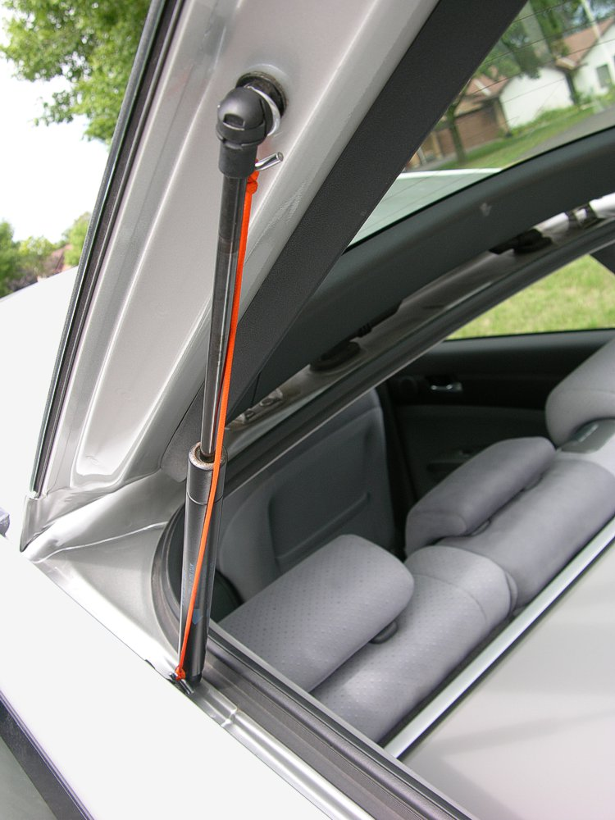 | Connect a piece of string on each end the pressure-arm with hooks.  Just a simple restrictive device like this is all it takes. Preventing that pressure-arm from extending all the way reduces the height of the hatch when open. And when you shut it, the string simply folds into the slot for drainage.  The string (or light-weight rope) should be about 12 inches when stretched.  The hooks must only be 1/8 inch thick to fit properly. They can be any length.  To the left is a photo of the string attached. Below is a photo of it below installation.
 | Height Reduction | 

External Cargo

 | Roof-Rack | Removable & Lockable roof-racks can be used for kayaks, canoes, bikes, and cargo carriers.  Yakima is the brand shown in the photo below. Thule & Saris brands are also available.  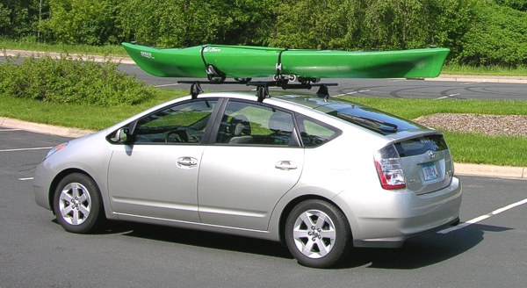
 | Roof-Rack | That particular configuration above uses the following rack components:  - Q-Towers (# 0124) $130  - Q-124 Clips (# 0724) $60  - 66” Round Bars (# 0410) $55  - Mako Saddles (# 4019) $60  - Hully Rollers (# 4028) $70  - Lock Cores (# 7204) $35  It’s about $375 retail to carry one kayak, and  an additional $130 for a second (as shown to the right). The rack can be used without the optional $35 lock cores.  To reduce noise and improve aerodynamics, this shield can be added: 44” Fairing (# 7048) $50 | 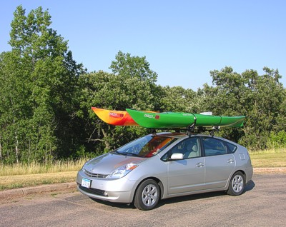
 | Tie-Down Eyelets | Prius is equipped with remarkably handy tie-down eyelets. Their original purpose was for ocean transport from Japan, to provide a convenient & reliable method of securing the car to the boat. Owners have found the very opposite to be true as well, securing a boat to the car. Located in each of the 4 corners under the bumpers, you’ll find those handy metal eyelets for tying down large roof cargo like a canoe.
 | Receiver-Hitch | Custom aftermarket receiver-hitches have been built for Prius. That is another option available for carrying bikes on the back of the vehicle.

 | Strap-On Rack | Inside is the ideal method of transporting bikes. But if you require that room for carrying people or cargo instead, a strap-on rack can be used.
 | Strap-On Rack | 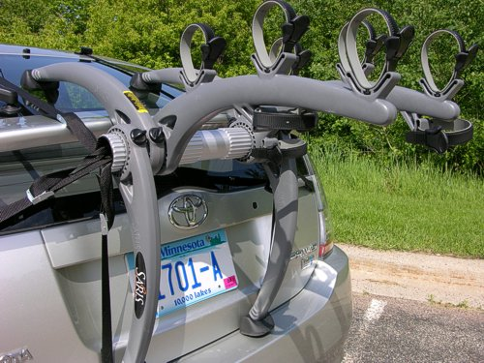 | The photo on the left shows the 3 bike model of the Saris Bones rack.  It straps on very securely with only a minimal amount of pressure on the glass. Most of the bike weight is supported legs on the bumper.  The photo above shows how even an odd shaped recumbent bike can be carried along with a traditional 12-speed bike.
 | Strap-On Rack | 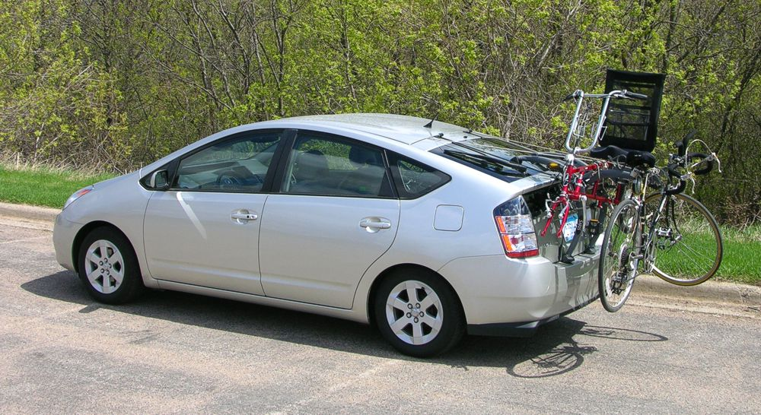  If you desire an extremely secure connection, for extra support of very heavy loads, there is a little known option available. The metal anchors for the hatch itself are outside of the water-seal, which makes them the ideal location for tying a rope to. Just open the hatch, the hinges are part of those anchors. Extend a rope from there to the strap-on rack or the bikes themselves.

 | Safety Catch | It never hurts to have a safety catch for protecting your external cargo. After all, when towing a trailer, there’s always 2 chains used for the purpose of keeping cargo attached if the primary connection should slip. That same type of secondary ensure can be added for Prius when carrying items on the roof too.  The photo to the right illustrates where a rope can be connected for securing loads on the roof from the front.  Notice (below) that the hole is outside of the waterseal, so the rope does not interfere with the hood at all. |  | 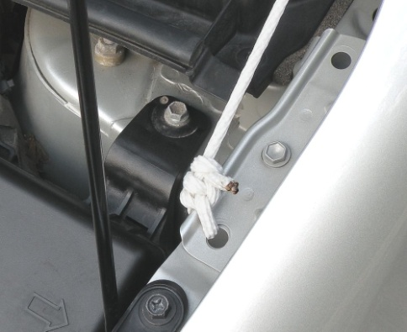
 | Safety Catch | 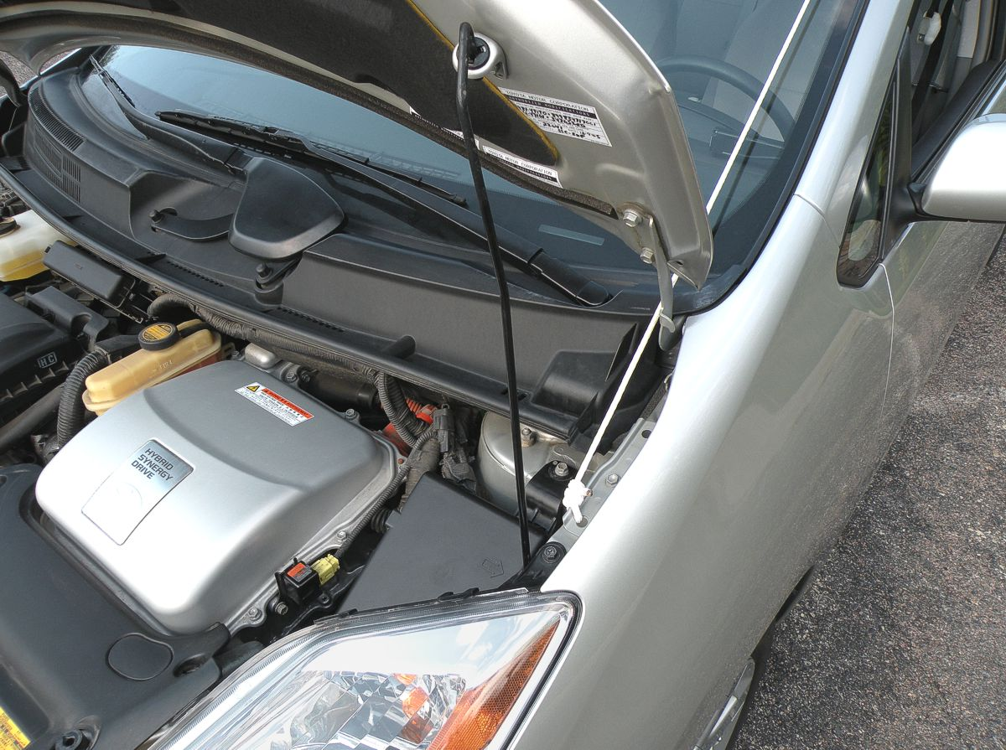
 | Safety Catch | 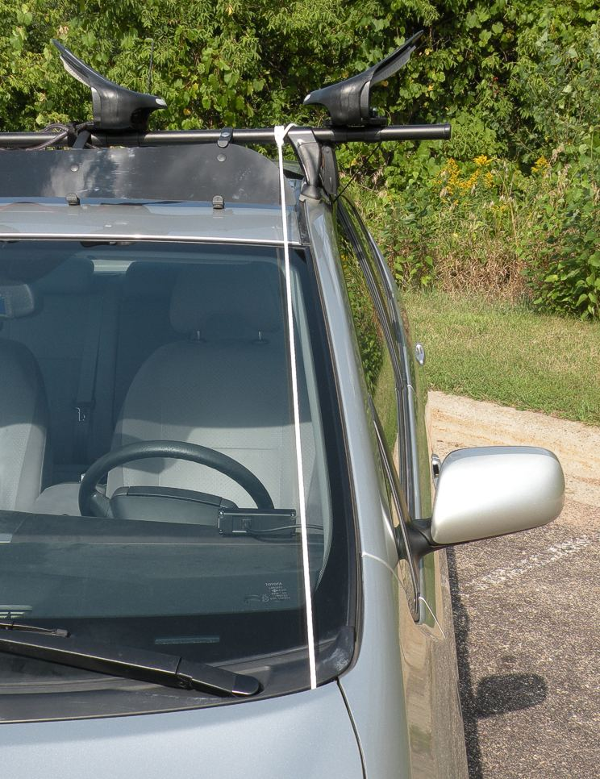 | With the hood shut, you can see how the rope nicely fits in the opening available.  From that point, you can attach it to anywhere on the rack that’s convenient. The purpose of preventing a slip backward while driving will easily be fulfilled. And being in the corner of your field-of-view makes it simple to verify status… for added confidence.  Do the same attachment on the passenger-side as shown here with the driver-side.
 |  | For further securing of a rack on the roof or to help hold cargo itself on the rear of the Prius (like bikes supported by a rack sitting on the bumper), there’s a place to attach a rope for that too.
 |  | 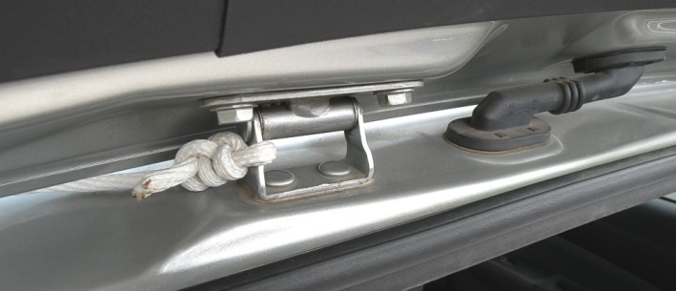 |  |  | The hinge for the hatch itself is a very sturdy connection point available that is outside the waterseal. Simply tie a rope to it as shown in the photo to the left.  Below is that rope connection viewed from the Prius in back.
 |  | 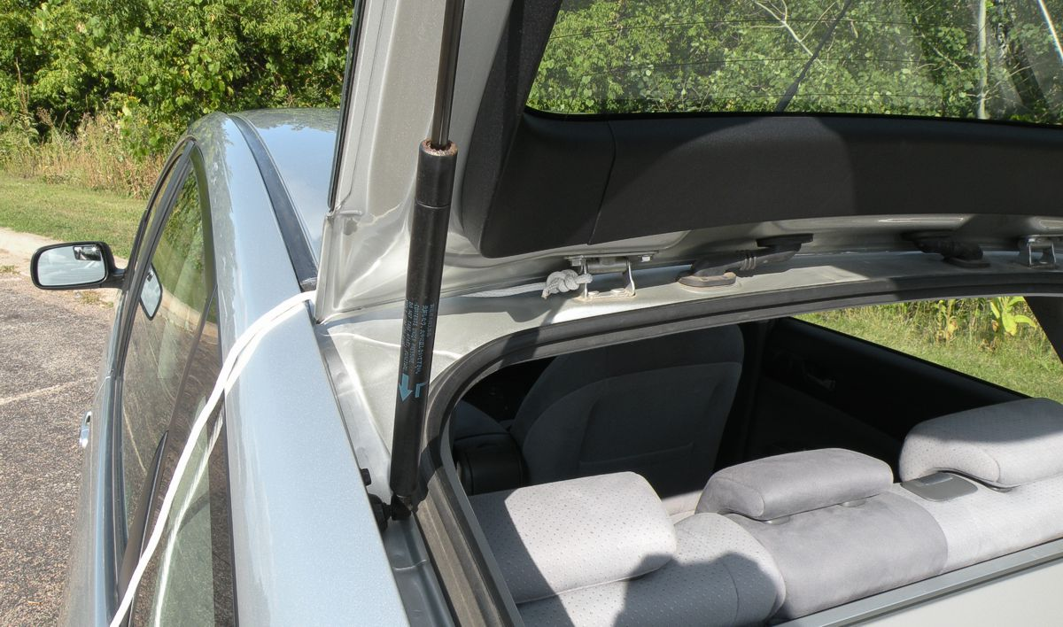
 |  | When the hatch is closed, the rope can be directed upward to help hold cargo above in place or back to help hold cargo on the rear. An excellent use for this is to stabalize a load of bikes on a strap-on rack, reducing any concern you may have for the weight swaying and it getting pushed by wind as you drive.
 |  | 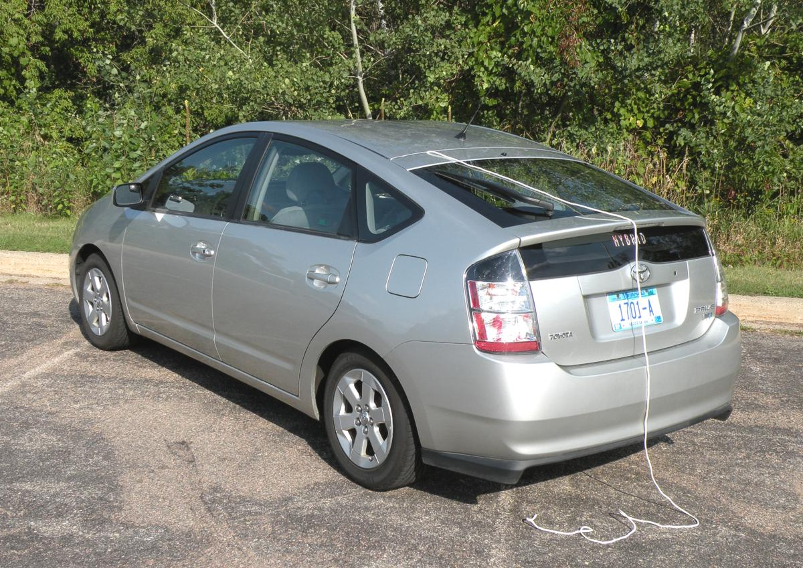

Side Mirrors

 | Blind-Spot | As with most all vehicles, Prius has a blind-spot immediately to the left-rear of the driver. The solution to that is carefully aiming the mirror on the side. You can also add a blind-spot mirror to it, the very same way as with other vehicles.  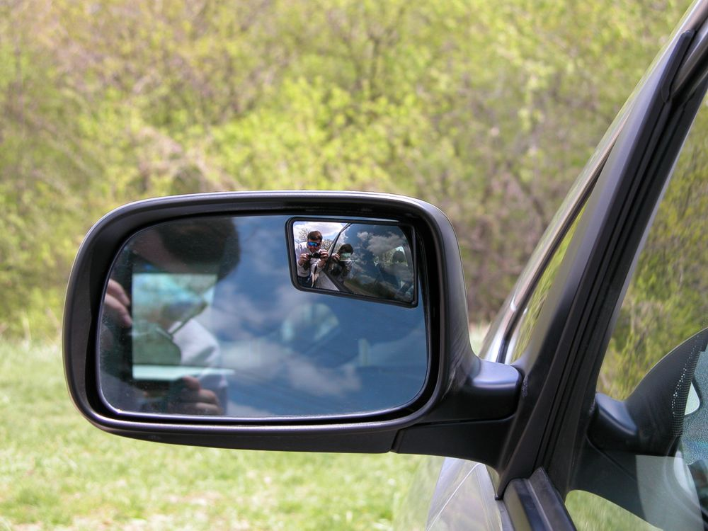  The photo above shows a blind-spot mirror installed, outside the driver-side door. (There’s just an adhesive sticker on the back of it. So installation only takes a moment.) The upper-right corner is the least intrusive location, since you won’t normally see a vehicle positioned there anyway.  It is recommended that you purchase two (one for each side of the car) made from high-quality hard plastic. The cost is around $6 for a set of that nicer type. That makes it easier to see fine detail and more resistant to water spots. In fact, you’ll find that the plastic stays cleaner in the winter than the glass of the big mirror.

Internal Storage

 | Hidden Drawer | This drawer often takes a very long time for owners to discover, since it is located underneath the cupholders between the front seats near the floor.  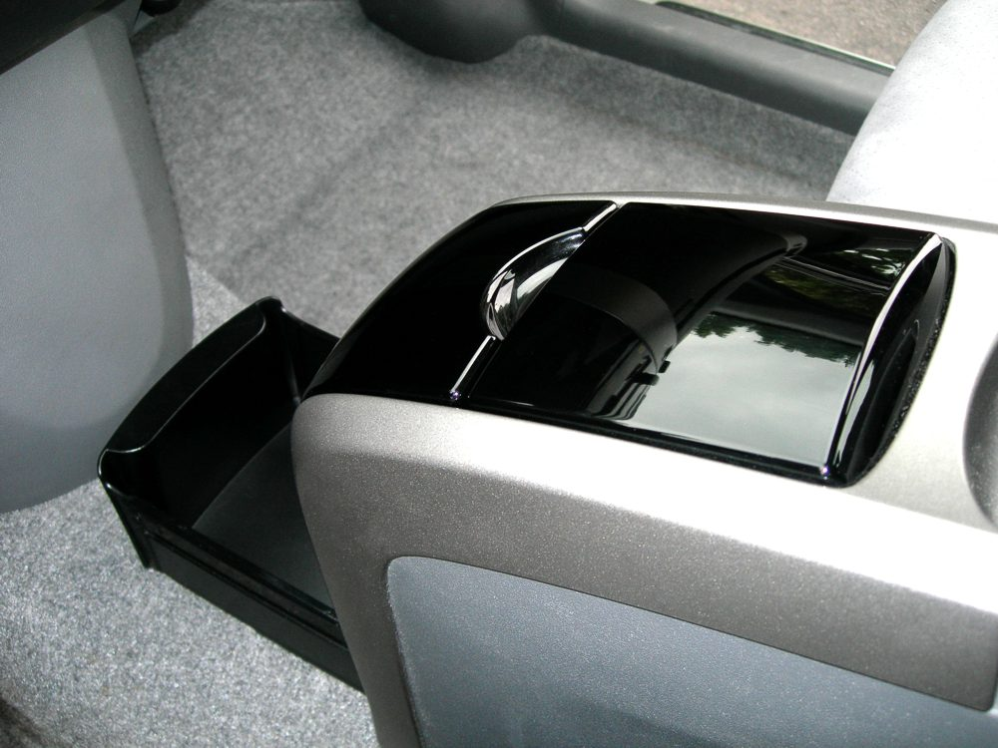  It is ideally for storing tissue. By removing them from the standard cardboard box, a surprisingly large stack can be neatly placed inside.

Operational Details

 | 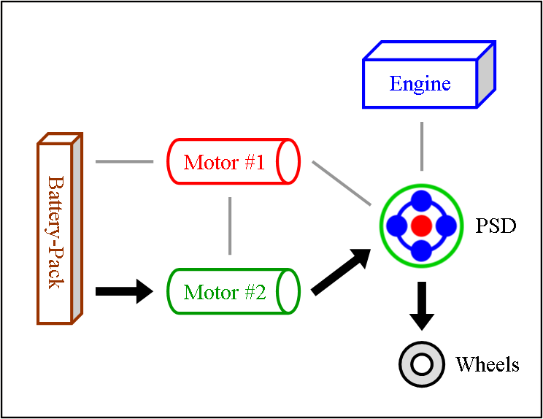 | Stealth or Electric-Only or Reverse  When power to the wheels is supplied entirely by the large motor using only the battery-pack, it is called “Electric-Only”. This can occur at any speed. The only requirement is that the use of gas by the engine must cease; however, the motion of the engine may still continue. When engine activity stops entirely, the mode is referred to as “Stealth”. This is an ability that is possible due to the PSD, a special device that “assist” hybrids do not have. Lastly, since there is no transmission or even any gears that shift, this is how reverse is provided. The large motor simply rotates backward.
 | 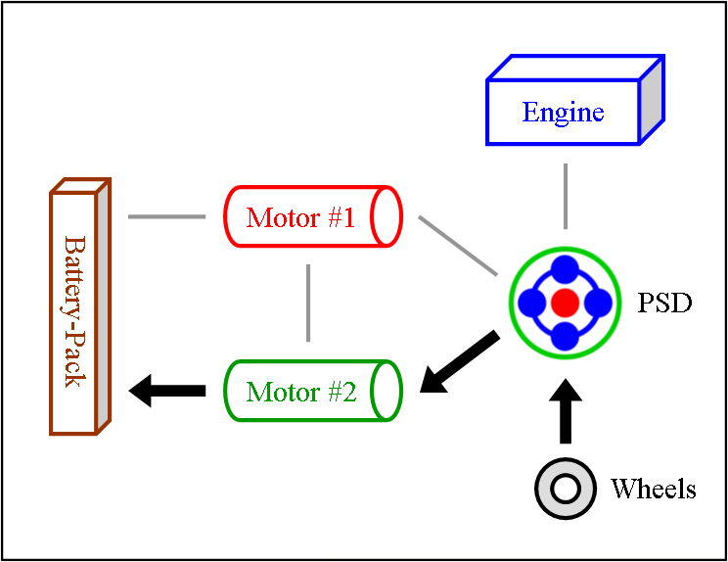 | Regeneration (Braking)  When the driver moderately steps on the brake-pedal, some energy that is normally wasted through friction from brake shoes & pads is instead routed backward through the hybrid system. This causes the large motor to now operate as a generator, which creates electricity to recharge the battery-pack with.  When the driver slams on the brake-pedal to emergency stop, the regeneration cycle is bypassed entirely. All energy is dealt with via the traditional shoe & pad method along with the anti-lock system.
 | 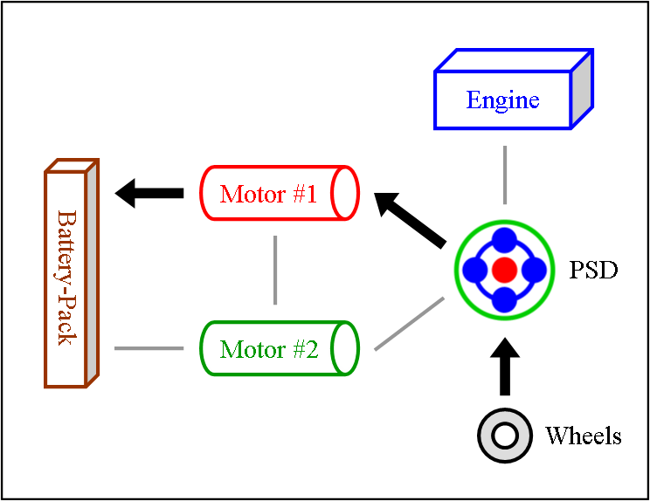 | Regeneration (Excess Capture)  Did you know that the “full” hybrid design provides regeneration electricity even when you don’t step on the brake-pedal? Most have no idea this efficiency gain exists. But it does. It works remarkably well too, and happens far more often than you’d expect. Whenever the vehicle slows down a little bit or it encounters a decline in the road, the small motor works as a generator powered by the wheels rather than the engine to capture that excess energy.
 | 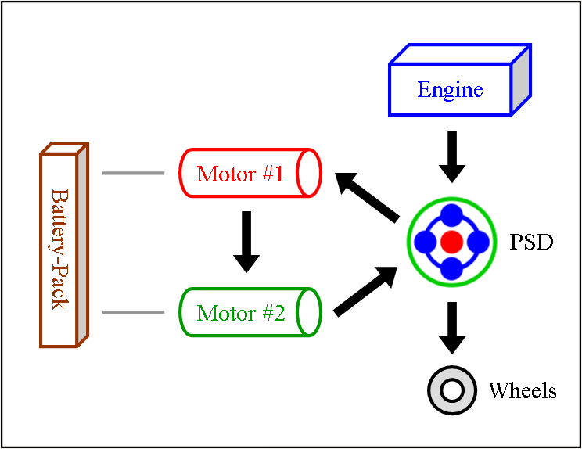 | Engine & Motor Drive  This is when all components of the “full” hybrid system except the battery-pack provide power. The engine spins the PSD, which then distributes 72% of that thrust to the wheels and 28% to the small motor. The spinning of the small motor generates electricity, which is immediately used by the large motor to supply additional thrust to the wheels. The benefit of this seemingly cumbersome distribution comes from the engine operating at a very efficient RPM while at the same time allowing the powerful yet efficient motor to contribute thrust. It also ensures longer battery-pack life by simply not using it.
 | 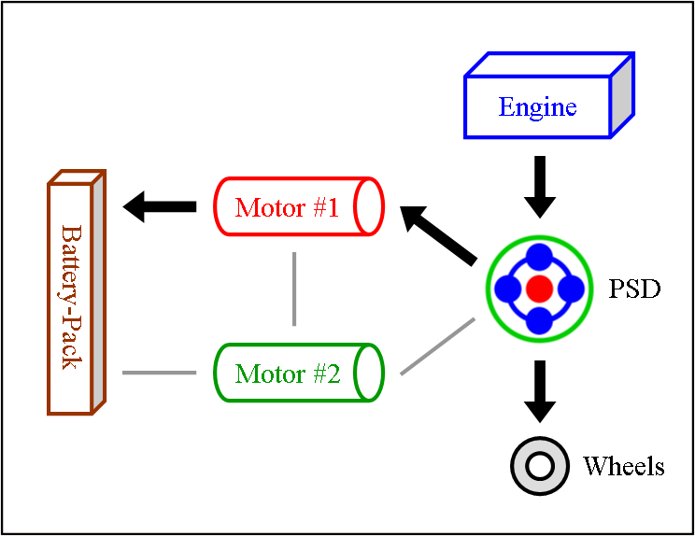 | Engine Drive + Charge  Sometimes the electricity being generated by the small motor isn’t needed. In that case, which happens frequently while cruising on a highway, it is sent to the battery-pack for recharging. Additionally, note that the A/C system is powered only by electricity, meaning it can take advantage of this situation… a design benefit that is often overlooked.
 | 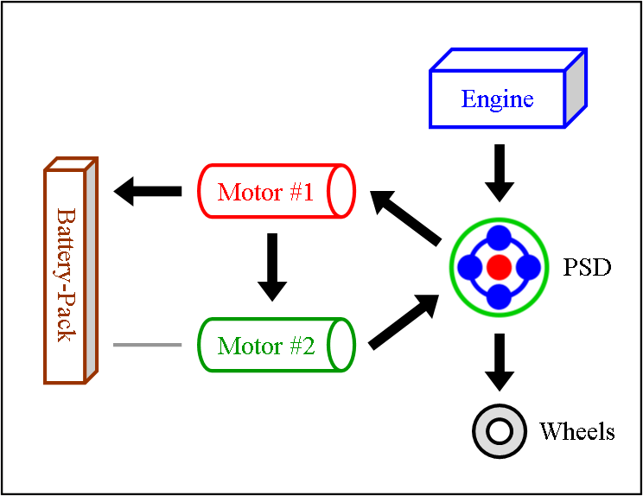 | Engine & Motor Drive + Charge  When the small motor is generating more electricity than what is needed by the large motor at that moment, the surplus is sent to the battery-pack. This is a benefit often overlooked, an efficiency gain due to running the engine at an optimal RPM (which also provides an efficiency gain). This is also the most common method in which hills are climbed, resulting in more stored electricity available at the top than when the climb began.
 | 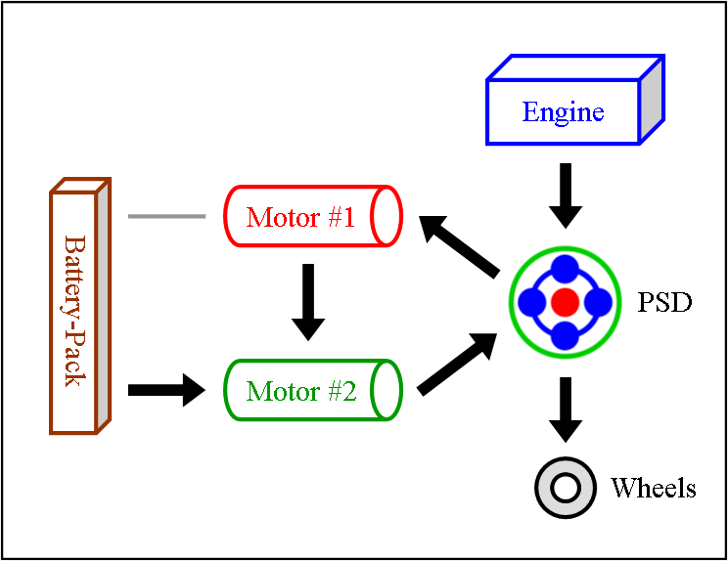 | Full Power or Gradual Slowing  At times when maximum thrust is required, like when merging onto a busy highway, the battery-pack will join in. This additional power is used by the large motor to produce even more thrust to the wheels than is normal needed. The same activity also occurs when slowing down gradually, allowing the engine to significantly reduce gas use without the driver noticing a power distribution change.
 | 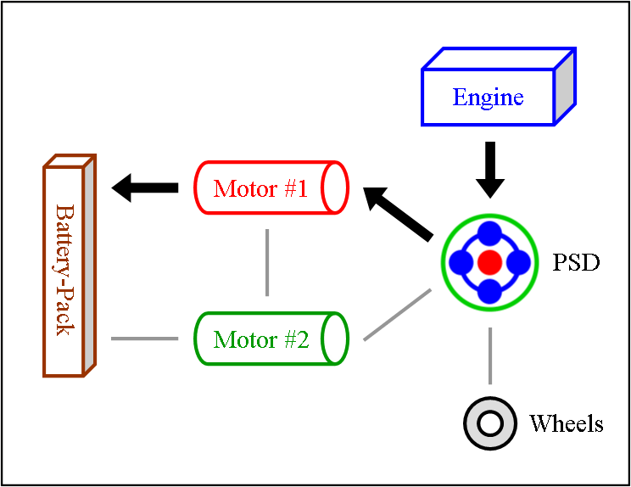 | Engine Heat  When the hybrid system is cold, it will run the engine to create heat for the catalytic-converter. This is required to enable the chemical reaction that cleanses emissions before leaving the tailpipe. Rather than allowing that power from the engine to be wasted while the vehicle is not moving, it is used by the small motor to generate electricity to recharge battery-pack. This same method will also occur when more heat is needed for the heater to keep you warm.
 | 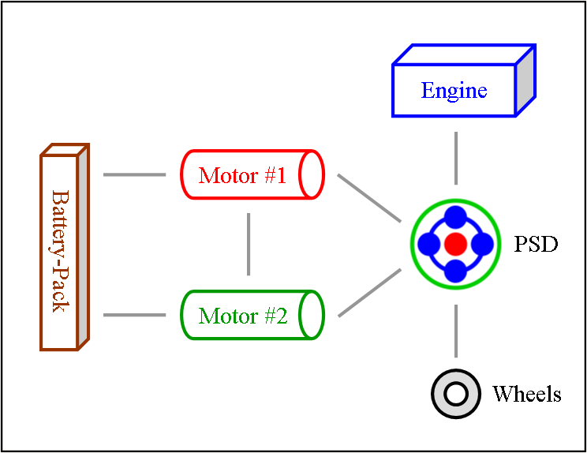 | Stand-By or Gliding  This is the state of the system at rest but still on. You’ll see it when power to the wheels isn’t needed; that’s both when the vehicle is stopped and when it is gliding. The engine may be idling or off.

Transmission

 | Type | "Planetary" is the type of CVT that Prius utilizes.  It has nothing in common with the other type of CVT currently available, called "Cone & Belt".
 | Design | Technically, Prius really doesn’t have a transmission since nothing ever shifts. There are no gears. There are only power-carriers. All they do is rotate, and they are permanently engaged.
 | Operation | The physical components within the "Planetary" CVT bear a striking resemblance to those within a differential (the power-transfer mechanism found on all vehicles). In fact, they even serve the same purpose.
 | Lifetime | Due to the fact that the "Planetary" CVT is nearly identical to that of a differential, the expectation is that it will last just as long. So you can confidently predict it will operate without worry for the entire lifetime of the vehicle.

Information Sources

 | Recent News | Hhttp://news.google.com/news?hl=en&lr=&ie=ISO-8859-1&q=Prius&sa=N&tab=wn
 | Toyota’s Website | Information directly from Toyota itself is available here... Hhttp://www.toyota.com/prius
 | Toyota Online | Repair Manual access & downloading for about $10 per day at... Hhttp://techinfo.toyota.com
 | Toyota Manuals | Available via credit-card from 1-800-622-2033  - 2004 Prius Repair Manual, volume 1: RM1075U1  - 2004 Prius Repair Manual, volume 2: RM1075U2  - 2004 Prius Repair Manual, volume 3: RM1075U3  - 2004 Prius Electrical Wiring Diagram: WED555U  - Prius New Car Features, 2004: NCF255U
 | Toyota Tech-Info | Technical Information System free downloads:  - Emergency Response Guide (Iconic)... Hhttp://techinfo.toyota.com/public/main/2ndprius.pdf  - Emergency Response Guide (Classic)... Hhttp://techinfo.toyota.com/public/main/1stprius.pdf  - Dismantling Manual... Hhttp://techinfo.toyota.com/public/main/priusdisman.pdf
 | Wikipedia | http://en.wikipedia.org/wiki/Hybrid_Synergy_Drive  A free online encyclopedia, featuring Iconic Prius information contributed by enthusiasts.
 | Enthusiast Forum | Hhttp://priuschat.com  A very informative forum where you can participate in online discussions related to Prius.
 | Owner Webpages | Hhttp://john1701a.com/prius/owners/owner-index.htm  Where find a variety of hosted Prius owner webpages with many photos.
 | Graham's website | Hhttp://www.ecrostech.com/prius/original/PriusFrames.htm  An owner’s website that thoroughly documents many aspects of the Prius.
 | john1701a's website | Hhttp://john1701a.com  This is a very large Prius owner website. As of 2/14/2009 the combined Classic & Iconic Prius content (172,275 miles combined) available consisted of: 876 webpages, 1683 digital photos, 1878 offline pages of personal logs, 83 animations, 66 wallpapers, 17 spreadsheets with graphs, 38 documents, 6 screen-savers, and 5 printable calendars, along with a few other Prius related items. There is also a collection of nature photos.
 | Fuel Economy Guide | http://www.fueleconomy.gov/feg/FEG2008.pdf  A very informative free publication provided by the EPA to help consumers understand the complex issues involved with fuel economy.
 | ScanGaugeII | 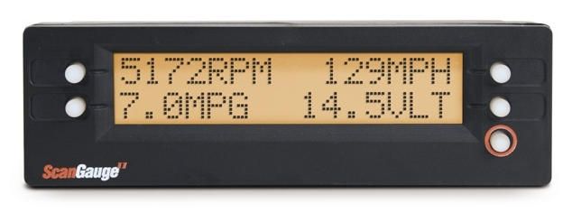  This is a scan-tool that provides live data via the standard ODB-II connector found in virtually every car now in use. That port which you connect it to is the same one the mechanics use to attach their very expensive diagnostic equipment. When Prius was new, there were no affordable offerings for a device of this sort. Things have changed. Owners wanting information beyond what the Multi-Display provides have a very realistic option now. It’s an empowerment device you’ll grow to really enjoy.  The following photo is an example of where the scan-tool could be mounted (using the included adhesive Velcro strips) in a Prius. That wire used to connect it is exposed only at the point shown; the remaining neatly tucks behind the water-seal of the door and underneath the steering-wheel up to the data-port. The setup is simple plug & play that takes only a few minutes without any tools.  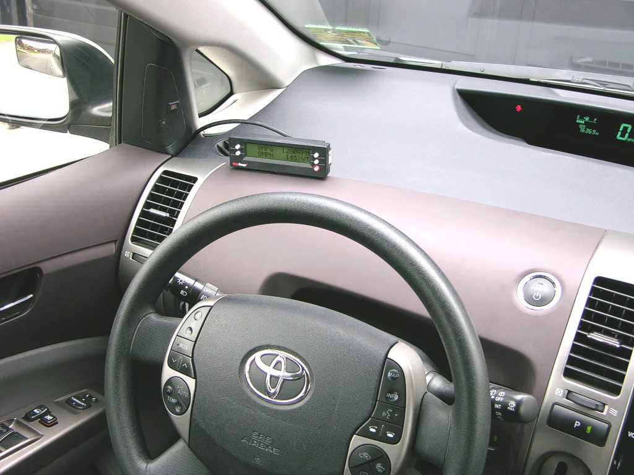  RPM, MPG, MPH, and Coolant-Temperature are the data that Prius owners are typically drawn to. There are 8 other gauge options to choose from. There are also 11 values which can be setup for automatic tracking for 4 sets of trip data.  “Check Engine” codes can also be both read and cleared. That’s very informative, allowing you to easily distinguish the difference between a simple error (like not tightening the fuel-cap enough) to a genuine part failure.  The color of the backlighting for the display itself can be changed too, by just selecting a different one from the extensive menu of options.  Hhttp://www.scangauge.comH for more information and to purchase ($169.95 including shipping).

Informational Materials

 | Info-Sheet (Iconic) | 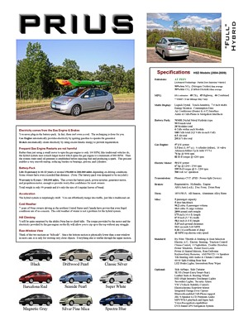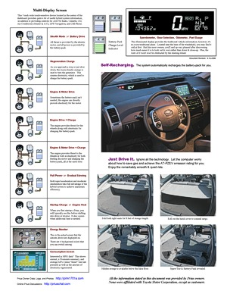
 | Info-Sheet (Iconic) | For an illustrated summary, refer to this document. It serves as a convenient means of introduction to all aspects of Prius.  Hhttp://john1701a.com/prius/prius-infosheet.htm
 | Energy Flow | 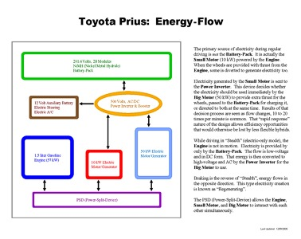 | For a basic understanding of the energy flow within the Prius hybrid system, download a copy of this document. Each of the major components are identified and the connection of each is explained in an easy to read format.  Hhttp://john1701a.com/prius/prius-energy.htm
 | Power-Split-Device | 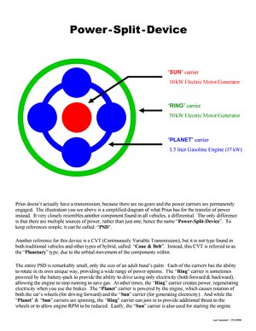 | For information about the heart of the hybrid system, read this document. This special device within Prius entirely eliminates the need for a traditional transmission. It is how the 2 electric motors and gasoline engine are able to seamlessly interact with each other.  Hhttp://john1701a.com/prius/prius-psd.htm
 | PSD (details) | 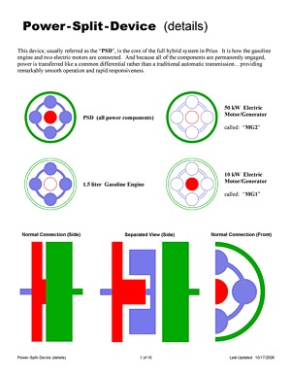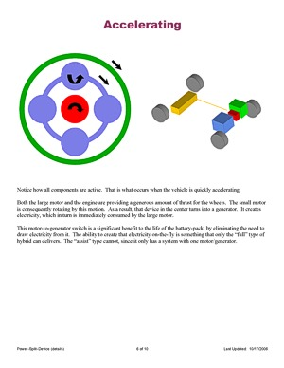
 | PSD (details) | This document provides a more in-depth look at the PSD. Without being overly technical, the illustrations describe how the wide variety of movements within the device relate to the operation of the hybrid vehicle.  Hhttp://john1701a.com/prius/prius-psd_details.htmH
 | Understanding Hybrids | 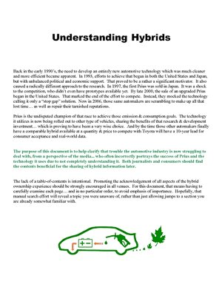 | The understanding of hybrids requires much more than just awareness of the efficiency values listed on the window-sticker and the fact that you don’t have to plug them in.  This document spells out the what you need to know.  Hhttp://john1701a.com/prius/prius-understanding.htm
 | Anti-Hybrid Analysis | 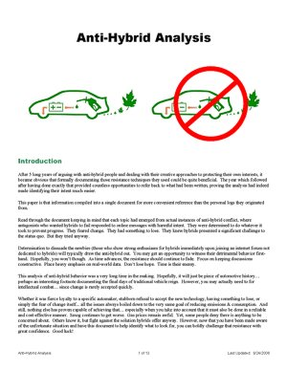 | Sadly, there are people that intentionally fight against hybrids, doing all they can to prevent their success.  Reading this will provide some insight. It is a summary of behaviors observed within online forums, based on several years of discussion messages posted about hybrids.  Hhttp://john1701a.com/prius/anti-hybrid_analysis.htm

 | Hybrid Types | 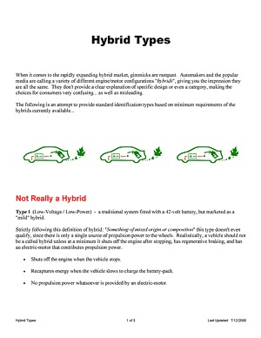 | There is a more diverse collection of hybrid system designs than most people realize.  This document helps by identifying and explaining the different types available.  Hhttp://john1701a.com/prius/hybrid-types_print.htm
 | Type: FULL | 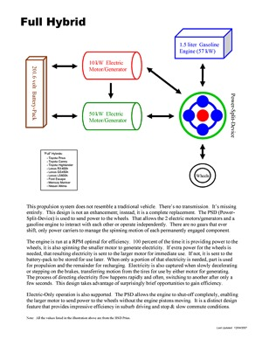 | The most dynamic of the hybrid types is known as "Full", since it includes a second electric motor to provide some abilities not available from lesser designs.  Prius is this type of hybrid.  Hhttp://john1701a.com/prius/hybrid-type_full.htm
 | FULL (details) | 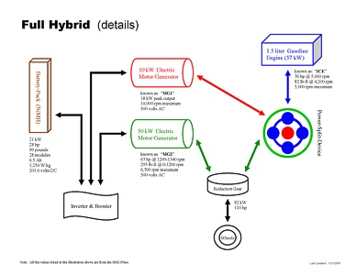 | For a more detailed illustration of the "Full" hybrid type, refer to this document.  Hhttp://john1701a.com/prius/hybrid-type_full_details.htm
 | Type: TWO-MODE | 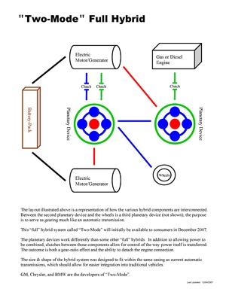 | This alternate variety of the "Full" hybrid is a configuration known as "Two-Mode". It adds another power-split-device for electric motor and engine interaction, plus multiple clutches.  This document highlights the differences you should be aware of.  Hhttp://john1701a.com/prius/hybrid-type_two-mode.htm
 | Type: ASSIST | 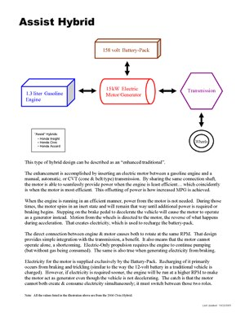 | The type of hybrid with only one electric motor that is directly integrated with an engine is known as "Assist".  There are benefits and limitations that those contemplating the purchase of this hybrid type should carefully consider.  Hhttp://john1701a.com/prius/hybrid-type_assist.htm
 | Type: SERIES | 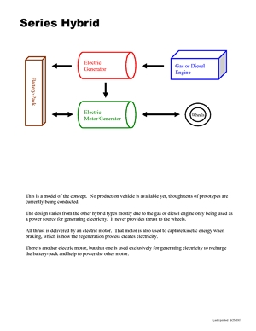 | A type of hybrid vehicle currently being concept tested. This document portrays the possible operational behavior it may deliver.  Hhttp://john1701a.com/prius/hybrid-type_series.htm
 | Misconceptions:  EFFICIENCY | 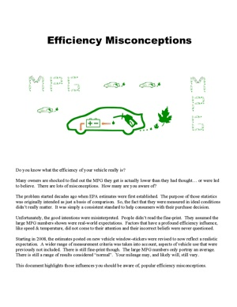 | Specific details about hybrid misconceptions related to efficiency of the system.  Hhttp://john1701a.com/prius/prius-misconceptions_efficiency.htm
 | Misconceptions:  HIGHWAY | 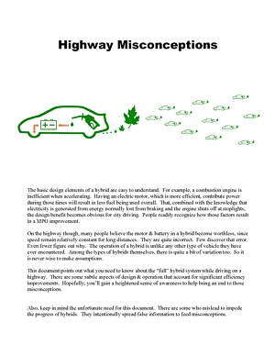 | Specific details about hybrid misconceptions related to operation while on the highway.  Hhttp://john1701a.com/prius/prius-misconceptions_highway.htm
 | Misconceptions:  WINTER | 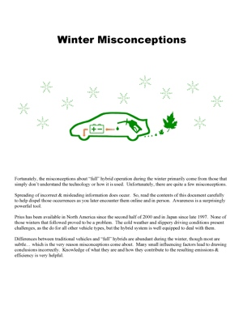 | Specific details about hybrid misconceptions related to conditions during the winter.  Hhttp://john1701a.com/prius/prius-misconceptions_winter.htm

 | Owner Summary | 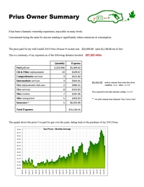 | Data from 5 years of Iconic Prius ownership summarized into charts & graphs.  http://john1701a.com/prius/prius-ownersummary.htm
 | Being Green | 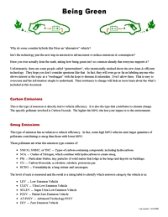 | Information you should be aware of when researching & discussing hybrids.  http://john1701a.com/prius/prius-beinggreen.htm
 | Requirements | 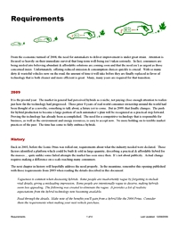 | Criteria that define genuine progress, the advancements required to significantly reduce emissions & consumption.  http://john1701a.com/prius/prius-requirements.htm

GLOSSARY

ABS | Anti-Lock Braking System, the feature which allows you to retain the ability to directionally control your vehicle during emergency deceleration.
AC | All modes of conditioning air inside the passenger area of the vehicle: Heating, Cooling, Venting
A/C | Condensing of air to cool it and to remove humidity.
Assist | Hybrid system with a small battery-pack and a single small electric-motor that provides peak power for the gasoline-engine during periods of acceleration.
AT-PZEV | Advanced Technology - Partial Zero Emission Vehicle
BAS | Belt-Alternator System – GM’s assist hybrid technology
"B" Mode | Engine Braking, (it isn't actually a gear) when you shift the transmission to this setting the engine will be used to slow down the car, it works similar to an exhaust brake used on the large semi-trucks (except the one on Prius is totally silent).
C | Celsius, a measure of temperature, (C * 1.8) + 32 = F, -25°C = -13°F, -15°C = 5°F, -5°C = 23°F,  0°C = 32°F, 5°C = 41°F, 20°C = 68°F, 25°C = 77°F, 30°C = 86°F
CAFE | Corporate Average Fuel Economy, the US system used to measure overall fleet efficiency
CARB | California Air Resources Board, an agency dictating emissions requirements for cars sold in California. (These are often more strict than Federal standards.)
CAT | Catalytic Converter, a vital component in the emissions system, typically utilizing a self-renewing metal
CC | Cruise Control
Cd | Coefficient of drag (0.29 for the Original & Classic Prius, 0.26 for the Iconic Prius)
CEL | Check Engine Light
Classic | The term used to identify the 2001 - 2003 model years of Prius.
CNG | Compressed Natural Gas
CO2 | Carbon-Dioxide, the type of vehicle emission that contributes to global warming.
CVT | Continuously Variable Transmission, Prius uses the "Planetary" design which functions as a power-split device to manage multiple sources of thrust; other CVT vehicles use a "Cone & Belt" design to adjusts power ratios.
Dinosaur | A very large, gas-guzzling, high-emission vehicle based on 20th century technology… doomed to extinction.
DRL | Daytime Running Lights
DVD | Digital Versatile Disc, used for the Navigational system in Prius
E10 | Blended engine fuel, 10% ethanol and 90% gasoline
E85 | Blended engine fuel, 85% ethanol and 15% gasoline
ECU | Electronics Control Unit, the amazing computer that monitors and controls the two motor-generators, the gas engine, the motion of the planetary gear set, the battery pack power levels etc. to provide the Prius' smooth acceleration and speed control.
Engine | The term used to refer to the device which runs on gasoline, utilizing combustion to push pistons to deliver power.
EPA | Environmental Protection Agency, the group responsible for rating the emissions & efficiency of vehicles sold in the United States.

EV | Electric Vehicle, powered exclusively by a battery-pack charged before use
F | Fahrenheit, a measure of temperature, (F - 32) / 1.8 = C, -15°F = -26.11°C, 0°F = -17.78°C, 15°F = -9.44°C, 32°F = 0°C, 40°F = 4.44°C, 60°F = 15.56°C, 70°F = 21.11°C, 80°F = 26.67°C
FCHV | Fuel Cell Hybrid Vehicle, a fuel-cell vehicle that takes advantage of hybrid technology including the use of a battery-pack
FOB | The device (introduced in 2003) used to unlock doors and start the hybrid system. By default, it works as a wireless remote for unlocking and is inserted into a slot in the dashboard for starting. As an option, it can be upgraded to control the SKS (formally known as SE/SS) feature. And note that there is actually a traditional key within which can be used for unlocking the driver's door manually.
FUD | Fear, Uncertainty, Doubt
Full | Hybrid system with a large battery-pack, a small electric-motor, at least one large electric-motor, and a gasoline-engine that combined provide a wide variety of combustion & electric propulsion abilities.
GPS | Global Positioning System, this is the part of the Prius Navigation System that identifies your exact location on Earth.
Greenwash | To intentionally mislead with respect to environmental benefits.
HEV | Hybrid Electric Vehicle
HID | High Intensity Discharge, bulbs used for headlights; illumination is created using an arch electricity instead of a traditional filament
HSD | Hybrid Synergy Drive - Toyota's modular hybrid design, implemented starting with the 2004 Prius with other vehicles now also using it.
HOV | High Occupancy Vehicle - used to describe the restricted "diamond" lanes on highways
HP | Horsepower, indicating a unit of power, a measurement different from torque
ICE | Internal Combustion Engine
Iconic | The term used to identify the 2004 - 2009 model years of Prius.
IMA | Integrated Motor Assist - Honda's hybrid technology
km | Kilometer, a measure of distance, 1 kilometer is equal to 0.6214 mile
kW | Kilowatt, an electrical measurement unit used when describing Prius power consumption & storage
LEV | Low Emission Vehicle, once the cleanest designation, but no surpassed by several levels of reduced emissions
L/100km | Liters per 100 kilometers, the more common unit of efficiency measurement outside of the US and UK
LMPG | Lifetime Miles Per Gallon
LRR | Low Rolling Resistant - used to describe minimum friction tires
MD | Multi-Display - the touch-sensitive liquid-crystal screen on the dashboard of Prius
Mi | Mile, a measure of distance, 1 mile = 1.6093 kilometers
MG | Motor Generator, an electric motor which can either provide motive power when electrically driven or generate electricity when mechanically driven.
MG1 | The smaller Prius electric motor. It is three-phase AC permanent-magnet synchronous motor/generator starts the ICE, controls the CVT, and generates the electricity (by using thrust from the ICE and deceleration power from slowing before the brake-pedal is pushed) to charge the battery-pack and/or feed the larger motor.
MG2 | The larger Prius electric motor. It is three-phase AC permanent-magnet synchronous motor/generator drives the wheels and generates electricity (from regenerative braking) to recharge the battery-pack.

Motor | The common term used to refer to the power device which operates using electricity.
MPG | Miles Per Gallon
MSRP | Manufacturer's Suggested Retail Price
MY2001 | Model Year 2001 (which became available in the United States the summer of 2000)
NAV | DVD-based GPS Navigation System, used in Prius
NiMH | Nickel-Metal Hydride, the type of modules used in the Prius battery-pack
NOx | Nitrogen Oxides, that type of vehicle emission that contributes to smog
NVH | Noise, Vibration, Harshness
OEM | Original Equipment Manufacturer, components directly from the automaker
OPEC | Organization of the Petroleum Exporting Countries
Original | The term used to identify the 1998 - 2000 model years of Prius (which were only available in Japan).
Priustoric | All that transpired before the Prius
PHEV | Plug-In Hybrid Electric Vehicle
PPM | Parts Per Million, the scale at which emissions are common measured, literally a count of matter within a unit
PSD | Power-Split Device, the planetary gear set which divides power between the ICE and the two electric motor-generators, also functions as the continuously-variable transmission.
PZEV | Partial Zero Emission Vehicle. (A manufacturer must eliminate evaporative emissions and ensure that the vehicle will run cleanly for its entire projected life. Even if the vehicle is just sitting in the driveway, it is still polluting. The source of this pollution is hydrocarbons emitted from the gas tank as gasoline slowly evaporates. To achieve PZEV certification, all evaporative emissions must be eliminated.)
R&D | Research & Development
SE | SKS: Smart-Entry. It is a proximity detection system that automatically senses a wireless transmitter (called a "fob") in your pocket or purse, allowing you to unlock the doors & hatch without the need to use a physical key or push a button on a remote.
SKS | Smart-Key-System (formally known as SE/SS: Smart-Entry & Smart-Start). It is the collective term used to describe all features of the wireless system available with some models of Prius.
SOC | State Of Charge, indicating the amount of stored electricity available in the battery-pack
SS | SKS: Smart-Start. It is proximity detection system that automatically senses a wireless transmitter (called a "fob") in your pocket or purse, allowing you to start the hybrid system without the need to use a physical key or push a button on a remote.
Stealth | Electric-Only driving (up to 42 MPH for Classic & Iconic Prius) without the engine in motion.
SRS | Supplemental Restraint System, better known as Airbags
SULEV | Super Ultra Low Emission Vehicle (only a few vehicles qualify for this clean rating category, Prius is among them)
THS | Toyota Hybrid System - Toyota's hybrid design for the Classic Prius
Torque | Measurement value indicating wheel turning force, a strength value different from horsepower
TRAC | Toyota Rent-A-Car, a program by which some have shortened the waiting time: when the demo/rental units reach a time/mileage it permits the dealer to sell them.

Turtle | Driving a Classic Prius with the battery-pack extremely drained of electricity, in conditions too hot (typically above 105 F degrees), or conditions too cold (typically below -10 F degrees), so that an orange "turtle" icon displays near the speedometer. This warns the driver to avoid forceful acceleration.
Two-Mode | GM’s full hybrid technology
ULEV | Ultra Low Emission Vehicle (as of the 2003 model-year there were 90 vehicle models in the United States that met the rating criteria)
V | Volt or Voltage, an electrical measurement unit used when describing attributes of Prius propulsion components.
VIN | Vehicle Identification Number, the worldwide identifier unique to each vehicle ever built
Vaporware | A term from the computer industry used to describe claims made by a company about a product that was never delivered. It sounded great in concept, but for whatever reason was impractical in the end. In other words, don't believe it until you actually see the product available for consumers to purchase.
VSC | Vehicle Stability Control, a safety feature that automatically engages side-specific braking for you when it detects the vehicle wheels slip; stepping on the brake is not necessary for the feature to work
ZEV | Zero Emission Vehicle

Prius Generations:
 | Original | Classic | Iconic | 2010
Engine HP  Engine kW  Engine RPM  Motor/Generator 2 HP  Motor/Generator 2 kW  Motor/Generator 2 Torque  Motor/Generator 2 RPM  Motor/Generator 1 kW (rated)  Motor/Generator 1 RPM  0-60 MPH (seconds)  Tire Width  Tire Diameter  Battery-Pack Energy (W/kg)  Battery-Pack Voltage  Battery-Pack Weight (lbs)  Battery-Pack Section (type)  Battery-Pack Section (count)  Hybrid-System HP  Hybrid-System kW  Hybrid-System Voltage | 58  43  4000  40  30  225  2000  15  4800  14.1  165  15  600  288  125  D-Cell  40  101  64  288 | 70  52  4500  44  33  258  5600  15  6500  12.5  175  14  900  273.6  110  Module  38  98  73  273.6 | 76  57  5000  67  50  295  6700  30  10000  10.1  185  15  1250  201.6  99  Module  28  110  82  500 | 98  73  5200  80  60  153  13500  42  10000  9.8  195  15  1250  201.6  110  Module  28  134  100  650

